**VISVESVARAYA TECHNOLOGICAL UNIVERSITY**

**“JnanaSangama”, Belgaum -590014, Karnataka.**



**LAB REPORT**

**on**

**Artificial Intelligence (23CS5PCAIN)**

***Submitted by***

**Suhan S (1BM23CS344)**

***in partial fulfillment for the award of the degree of***

**BACHELOR OF ENGINEERING**

***in***

**COMPUTER SCIENCE AND ENGINEERING**



**B.M.S. COLLEGE OF ENGINEERING**

**(Autonomous Institution under VTU)**

**BENGALURU-560019**

**Aug 2025 to Dec 2025**

**B.M.S. College of Engineering,**

**Bull Temple Road, Bangalore 560019**

(Affiliated To Visvesvaraya Technological University, Belgaum)

**Department of Computer Science and Engineering**



**CERTIFICATE**

This is to certify that the Lab work entitled “Artificial Intelligence (23CS5PCAIN)” carried out by **Suhan S (1BM23CS344),** who is bonafide student of **B.M.S. College of Engineering.** It is in partial fulfillment for the award of **Bachelor of Engineering in Computer Science and Engineering** of the Visvesvaraya Technological University, Belgaum. The Lab report has been approved as it satisfies the academic requirements in respect of an Artificial Intelligence (23CS5PCAIN) work prescribed for the said degree.

|  |  |
| --- | --- |
| Dr. Seema Patil  Professor  Department of CSE, BMSCE | Dr. Kavitha Sooda  Professor & HOD  Department of CSE, BMSCE |

**Index**

|  |  |  |  |
| --- | --- | --- | --- |
| **Sl.**  **No.** | **Date** | **Experiment Title** | **Page No.** |
| 1 | 30-9-2024 | Implement Tic –Tac –Toe Game  Implement vacuum cleaner agent | 1-6 |
| 2 | 7-10-2024 | Implement 8 puzzle problems using Depth First Search (DFS)  Implement Iterative deepening search algorithm | 7-12 |
| 3 | 14-10-2024 | Implement A* search algorithm | 13-18 |
| 4 | 21-10-2024 | Implement Hill Climbing search algorithm to solve N-Queens problem | 19-24 |
| 5 | 28-10-2024 | Simulated Annealing to Solve 8-Queens problem | 25-31 |
| 6 | 11-11-2024 | Create a knowledge base using propositional logic and show that the given query entails the knowledge base or not. | 32-36 |
| 7 | 2-12-2024 | Implement unification in first order logic | 37-42 |
| 8 | 2-12-2024 | Create a knowledge base consisting of first order logic statements and prove the given query using forward reasoning. | 43-48 |
| 9 | 16-12-2024 | Create a knowledge base consisting of first order logic statements and prove the given query using Resolution | 49-54 |
| 10 | 16-12-2024 | Implement Alpha-Beta Pruning. | 55-59 |

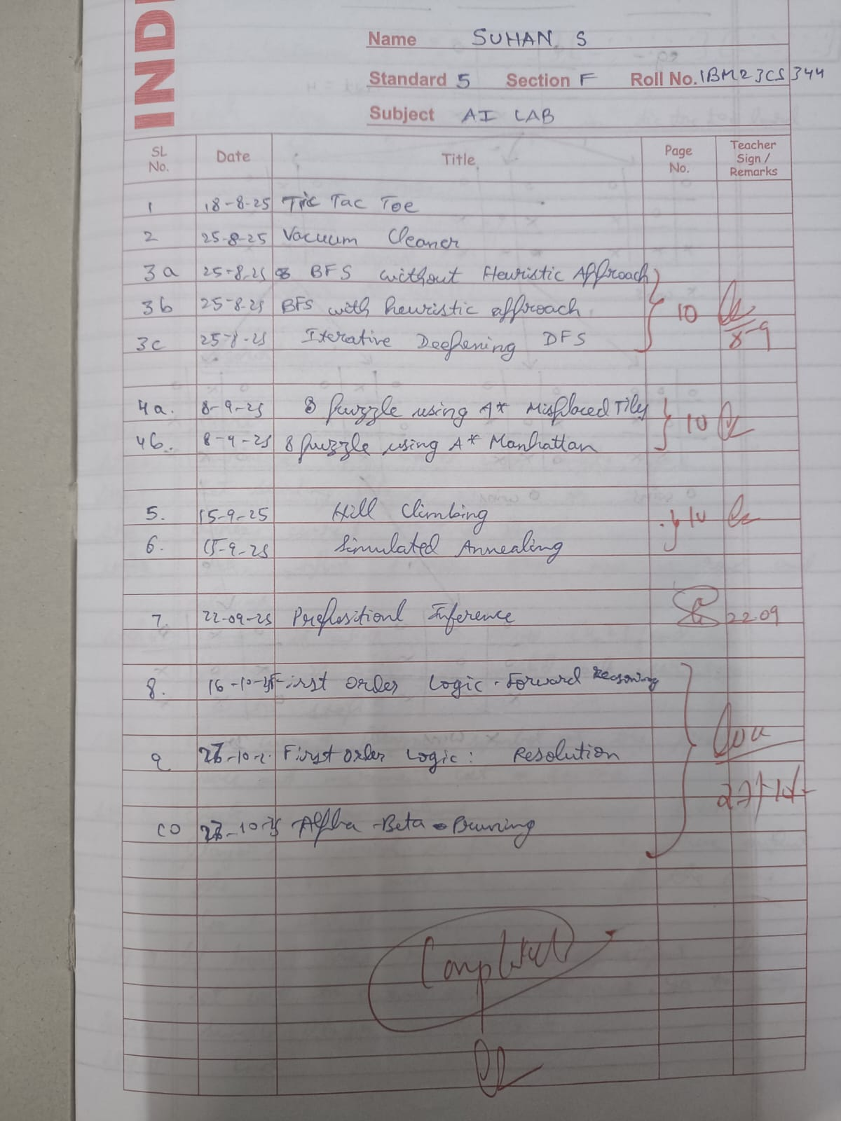Github Link:

https://github.com/suhan-s255/SUHAN-S-1BM23CS344-AI-LAB.git

**Program 1**

Implement Tic –Tac –Toe Game

Implement vacuum cleaner agent

Algorithm:

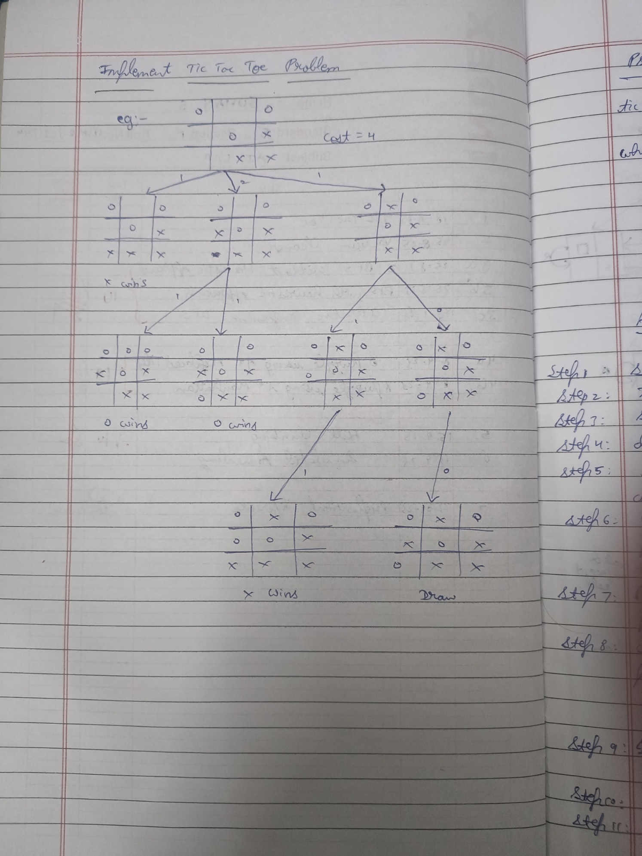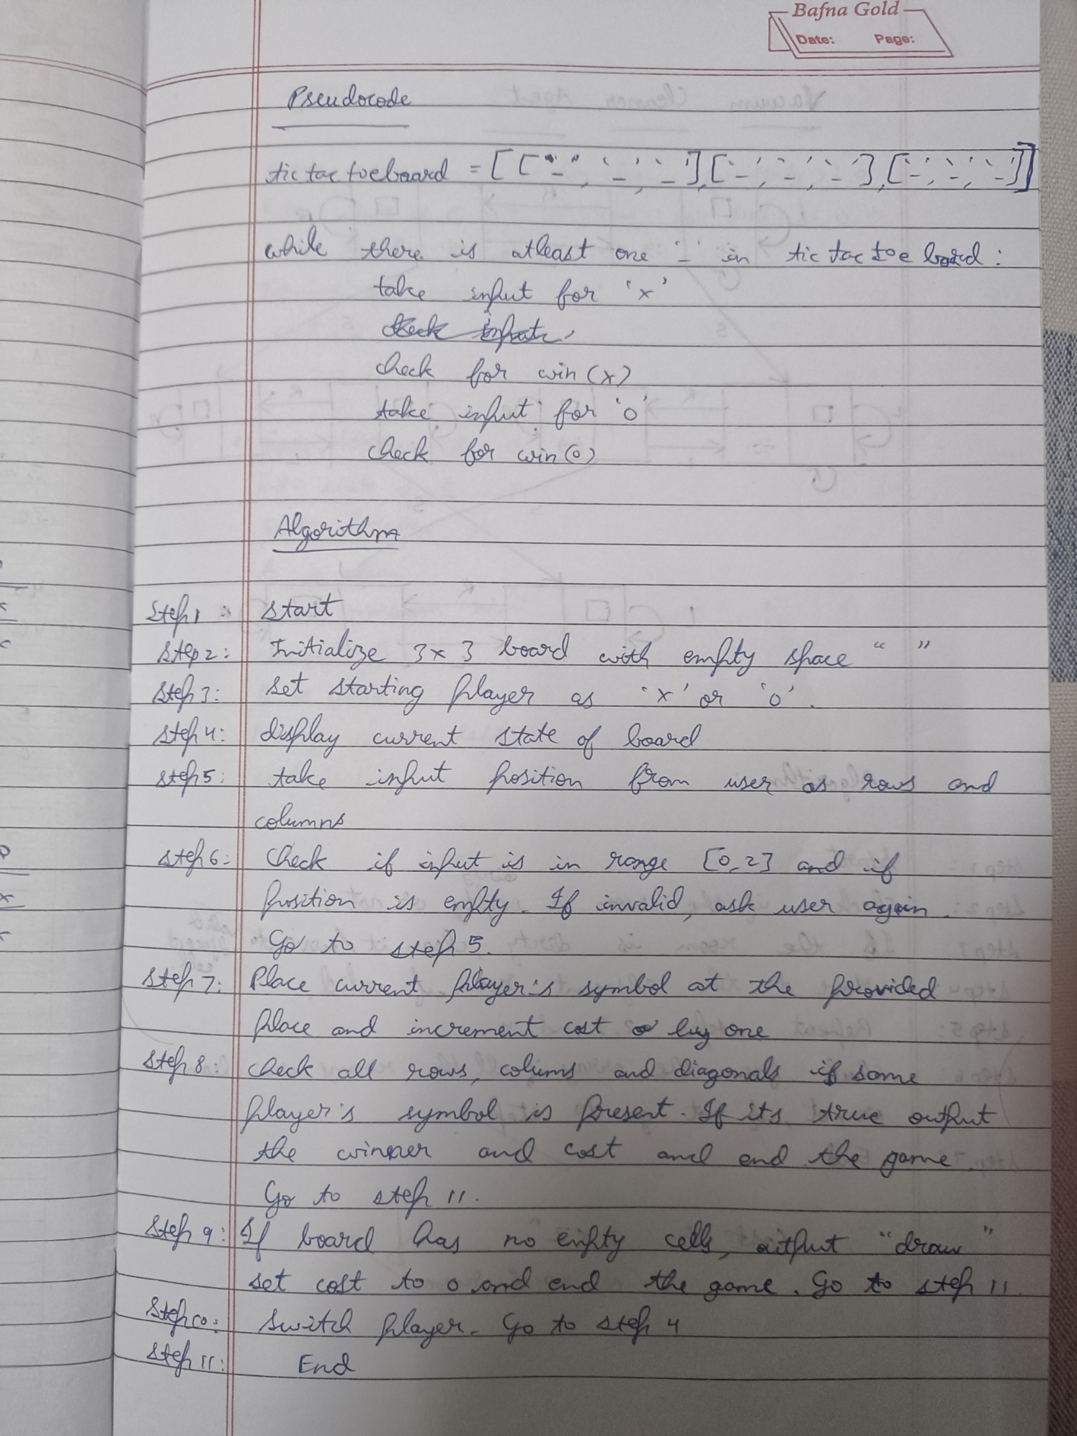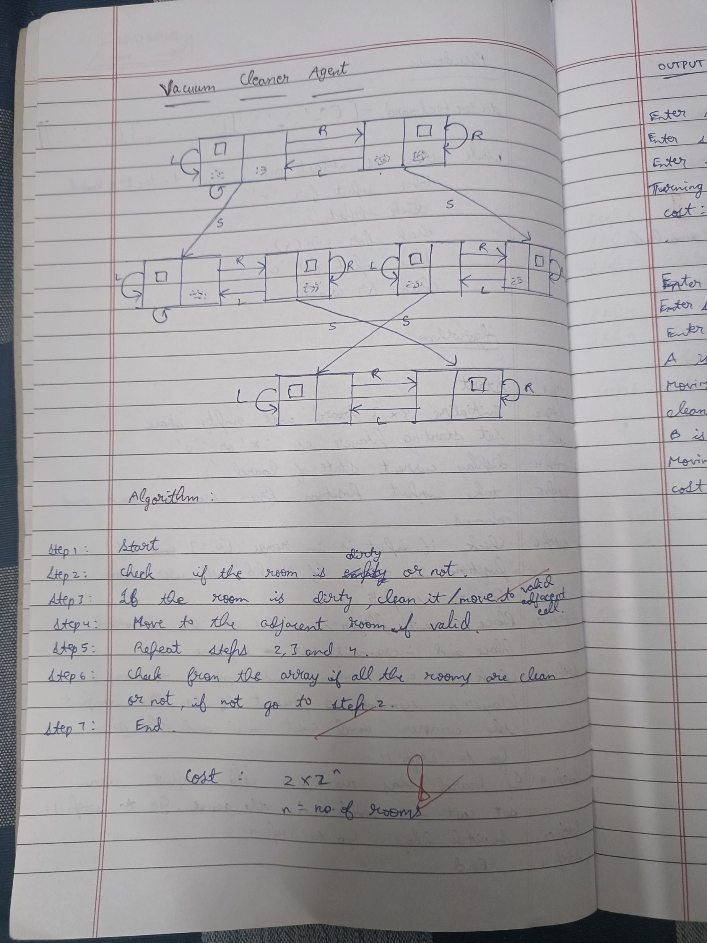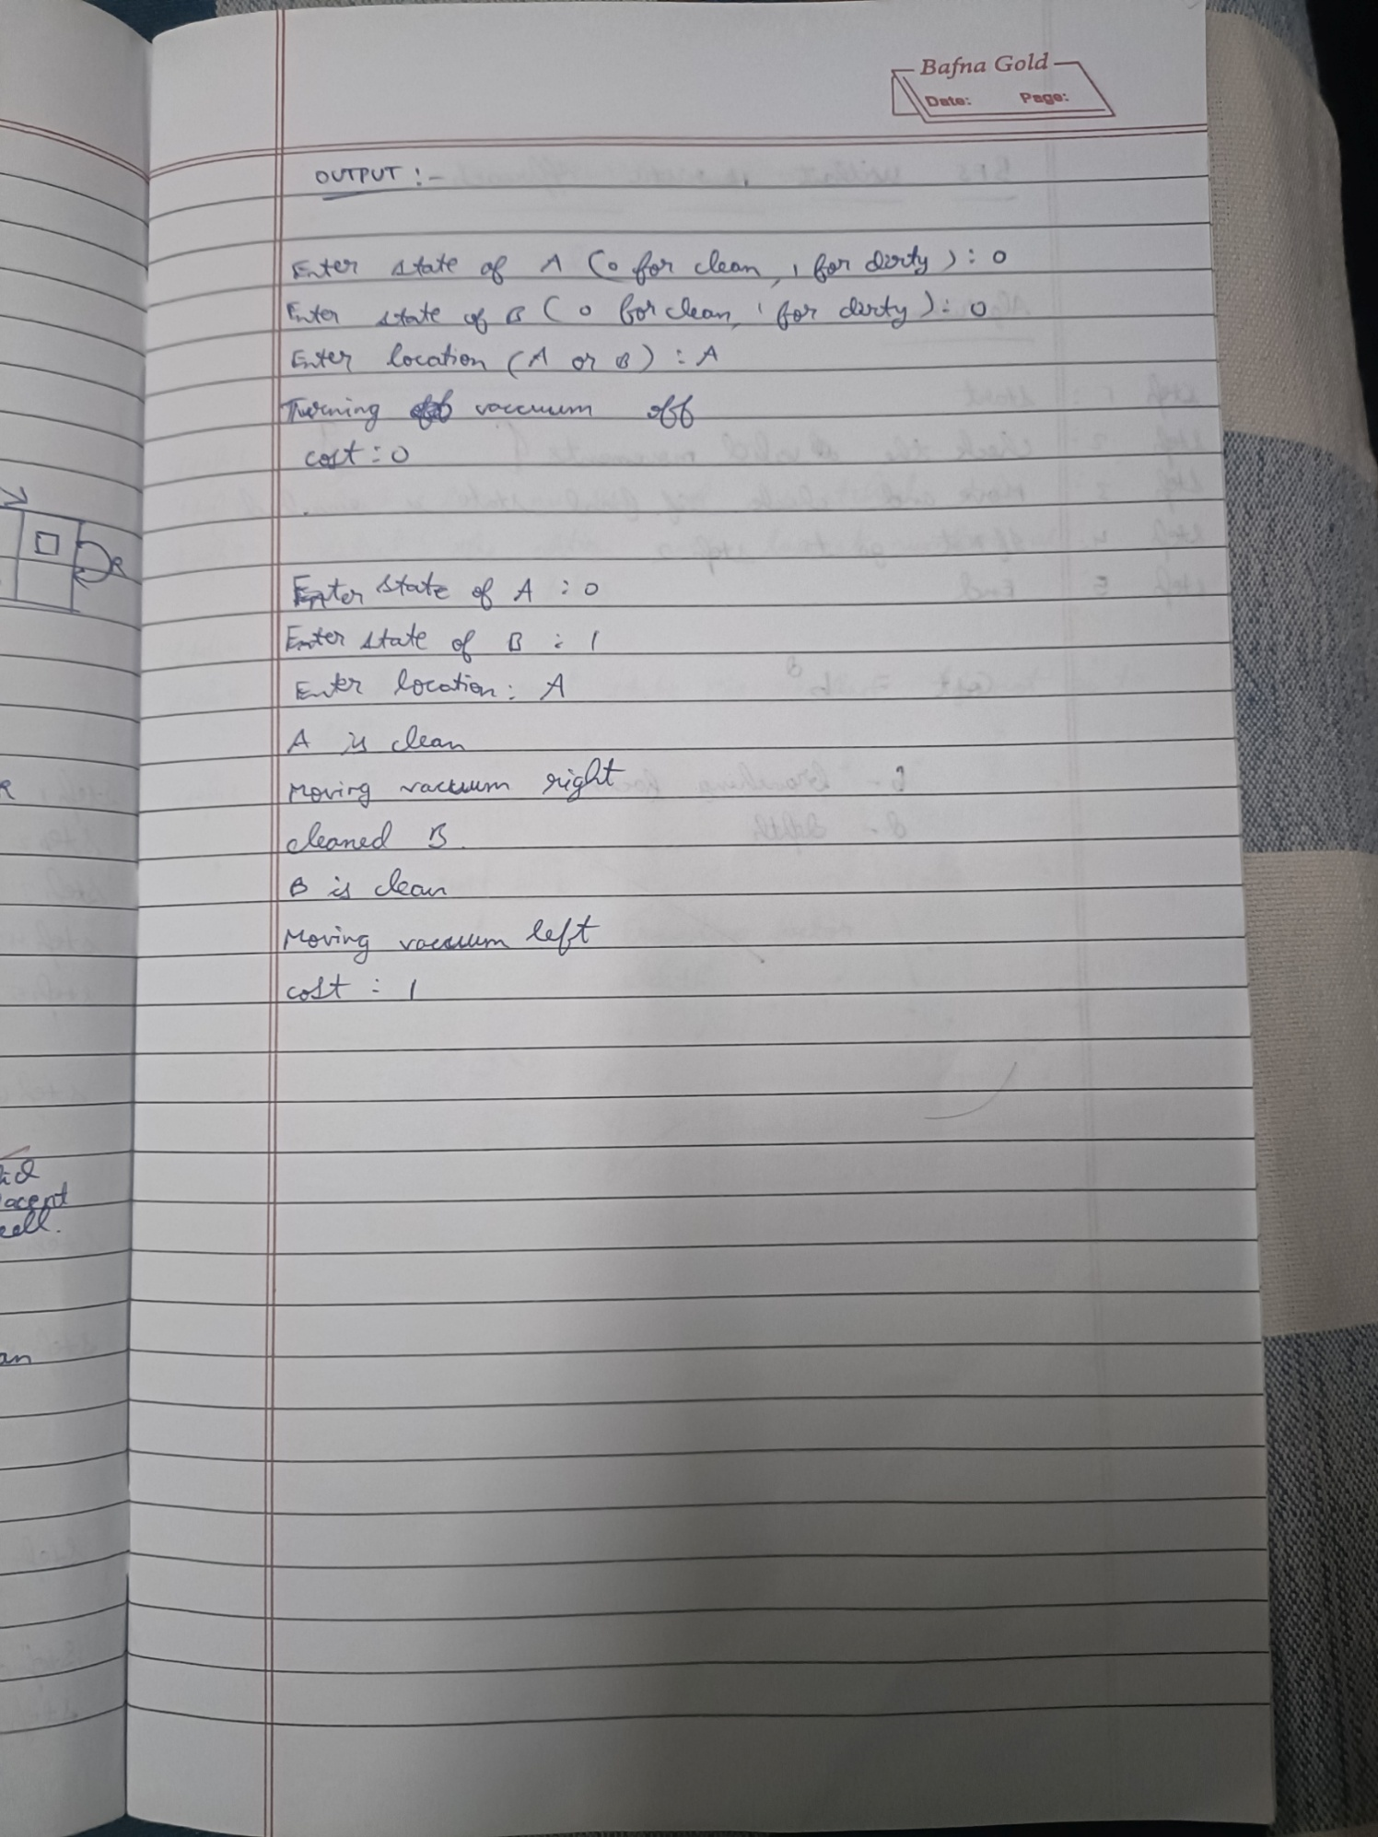

Code:

board = [['-', '-', '-'],

         ['-', '-', '-'],

         ['-', '-', '-']]

def print_board():

    for row in board:

        print(row)

def check_winner(player):

    for row in board:

        if all(spot == player for spot in row):

            return True

    for col in range(3):

        if all(board[row][col] == player for row in range(3)):

            return True

    if all(board[i][i] == player for i in range(3)):

        return True

    if all(board[i][2 - i] == player for i in range(3)):

        return True

    return False

def play_game():

    print_board()

    for turn in range(9):

        player = 'X' if turn % 2 == 0 else 'O'

        print(f"enter position to place {player}:")

        row = int(input()) - 1

        col = int(input()) - 1

        if board[row][col] == '-':

            board[row][col] = player

            print_board()

            if check_winner(player):

                print(f"{player} wins")

                print("Game Over")

                return

        else:

            print("Invalid move, try again")

            continue

    print("It's a draw")

    print("Game Over")

play_game()

def vacuum_cleaner():

    state_A = int(input("Enter state of A (0 for clean, 1 for dirty): "))

    state_B = int(input("Enter state of B (0 for clean, 1 for dirty): "))

    location = input("Enter location (A or B): ").upper()

    cost = 0

    rooms = {'A': state_A, 'B': state_B}

    if rooms['A'] == 0 and rooms['B'] == 0:

        print("Turning vacuum off")

        print("Cost: ", cost)

        print(rooms)

        return

    if location == 'A':

        if rooms['A'] == 1:

            print("Cleaned A.")

            rooms['A'] = 0

            cost += 1

        else:

            print("A is clean")

        print("Moving vacuum right")

        cost += 1

        if rooms['B'] == 1:

            print("Cleaned B.")

            rooms['B'] = 0

            cost += 1

        else:

            print("B is clean")

    elif location == 'B':

        if rooms['B'] == 1:

            print("Cleaned B.")

            rooms['B'] = 0

            cost += 1

        else:

            print("B is clean")

        print("Moving vacuum left")

        cost += 1

        if rooms['A'] == 1:

            print("Cleaned A.")

            rooms['A'] = 0

            cost += 1

        else:

            print("A is clean")

    print("Cost: ", cost)

    print(rooms)

vacuum_cleaner()

**Program 2**

Implement 8 puzzle problems using Depth First Search (DFS)

Implement Iterative deepening search algorithm

Algorithm:

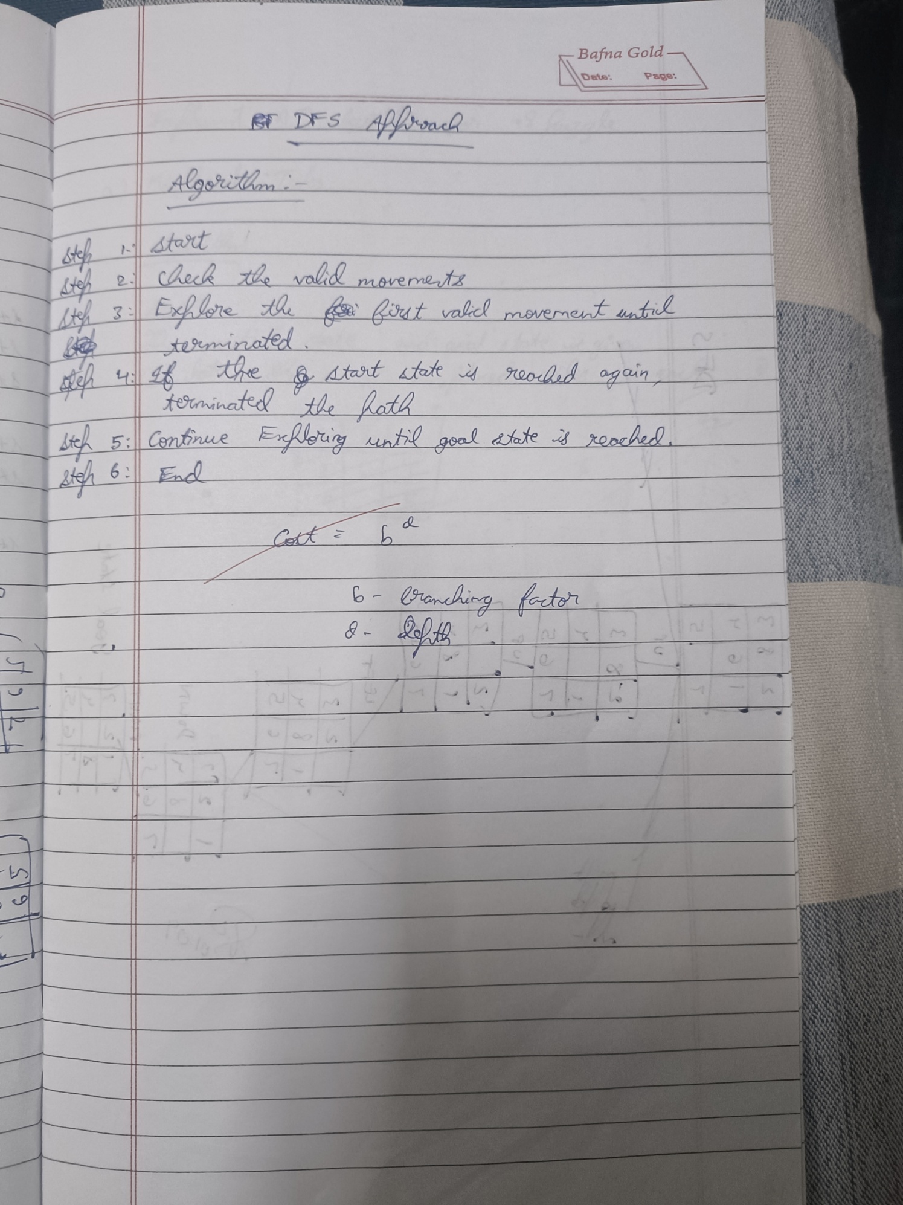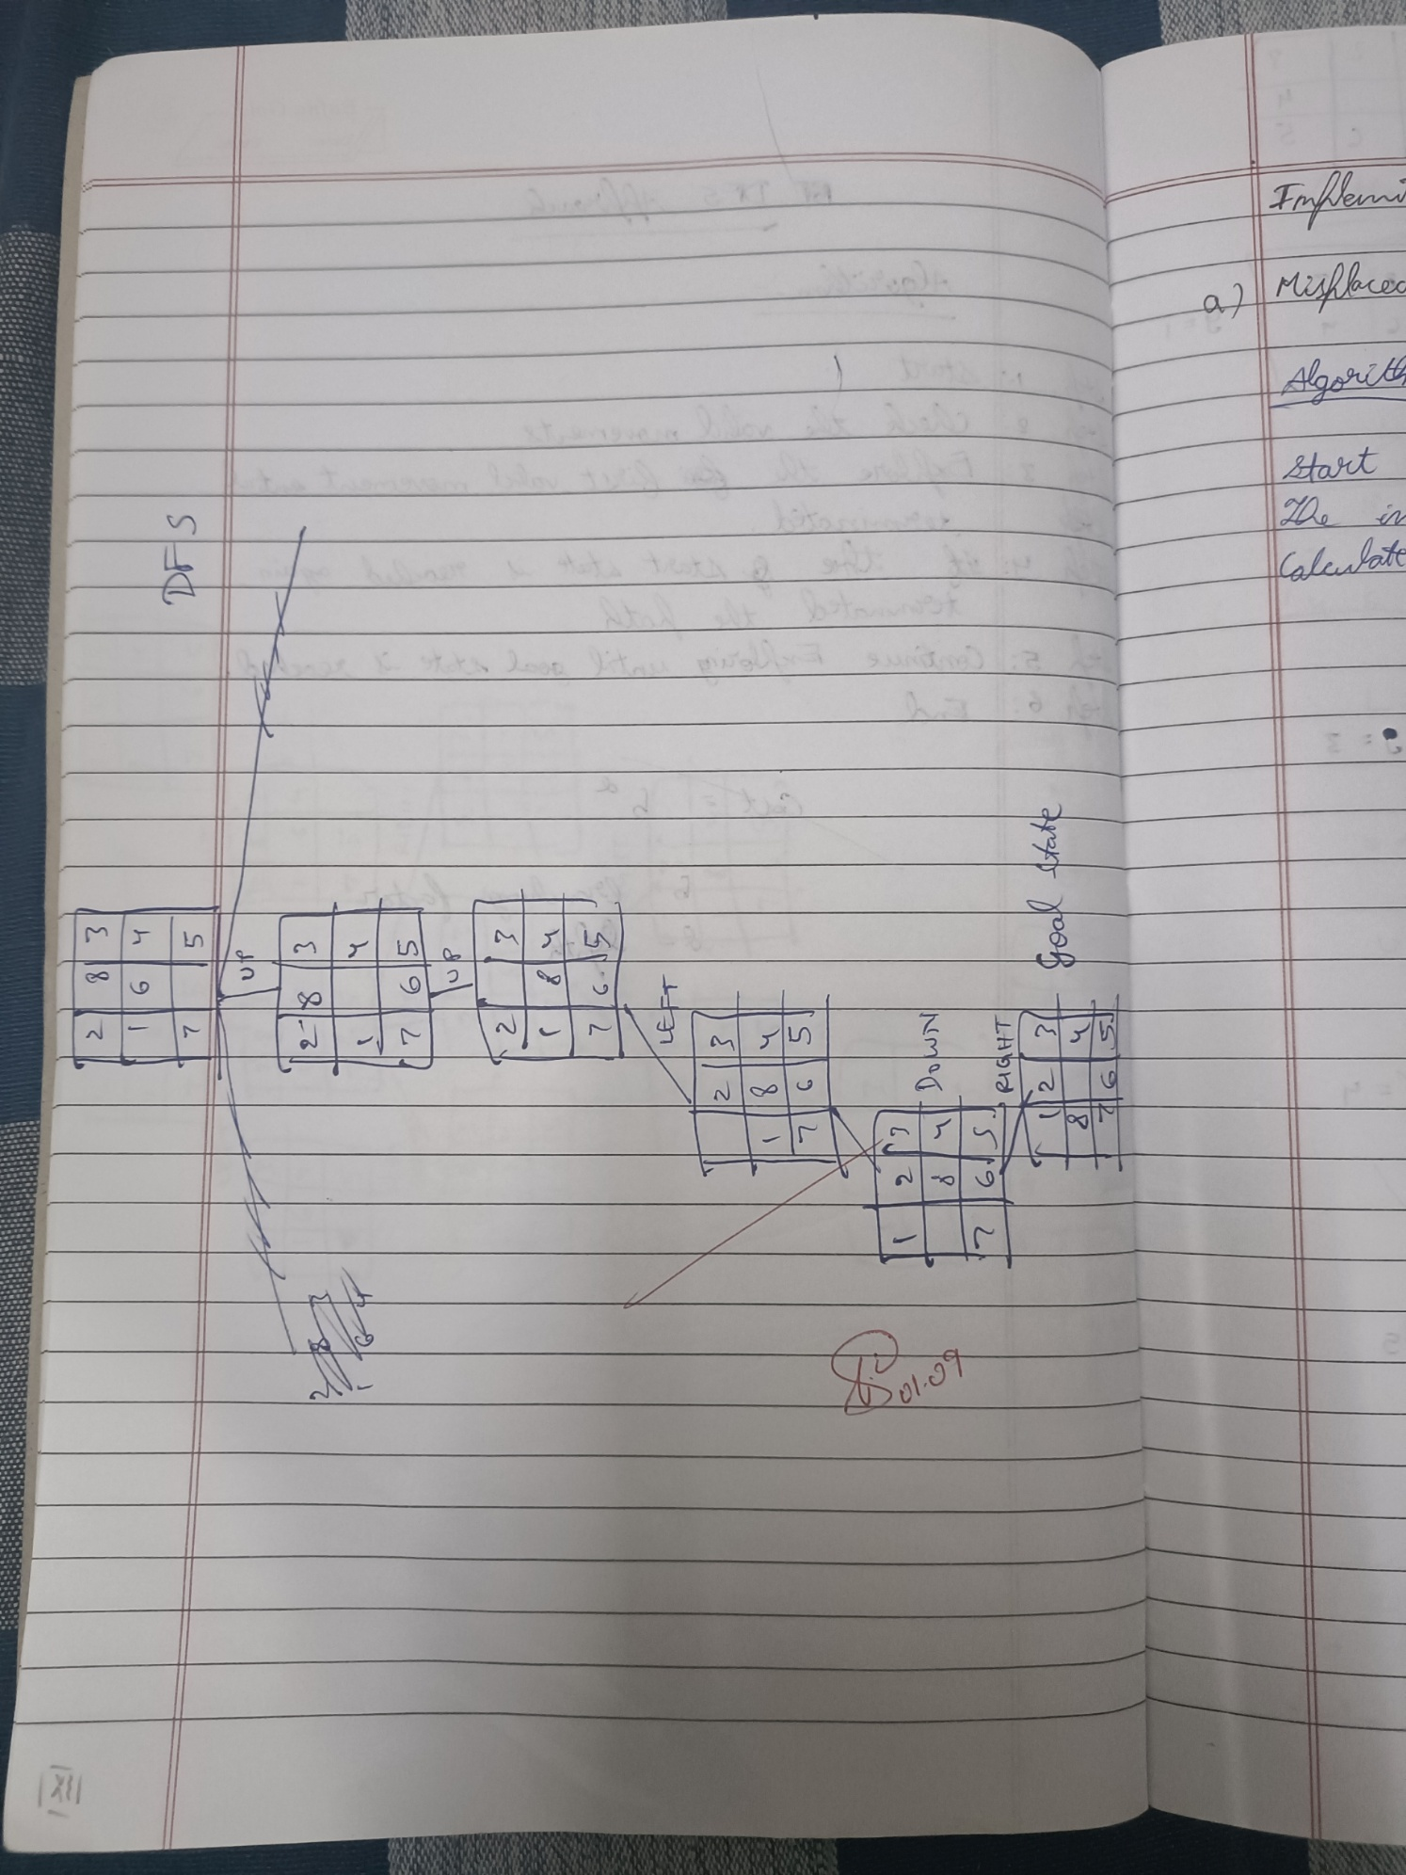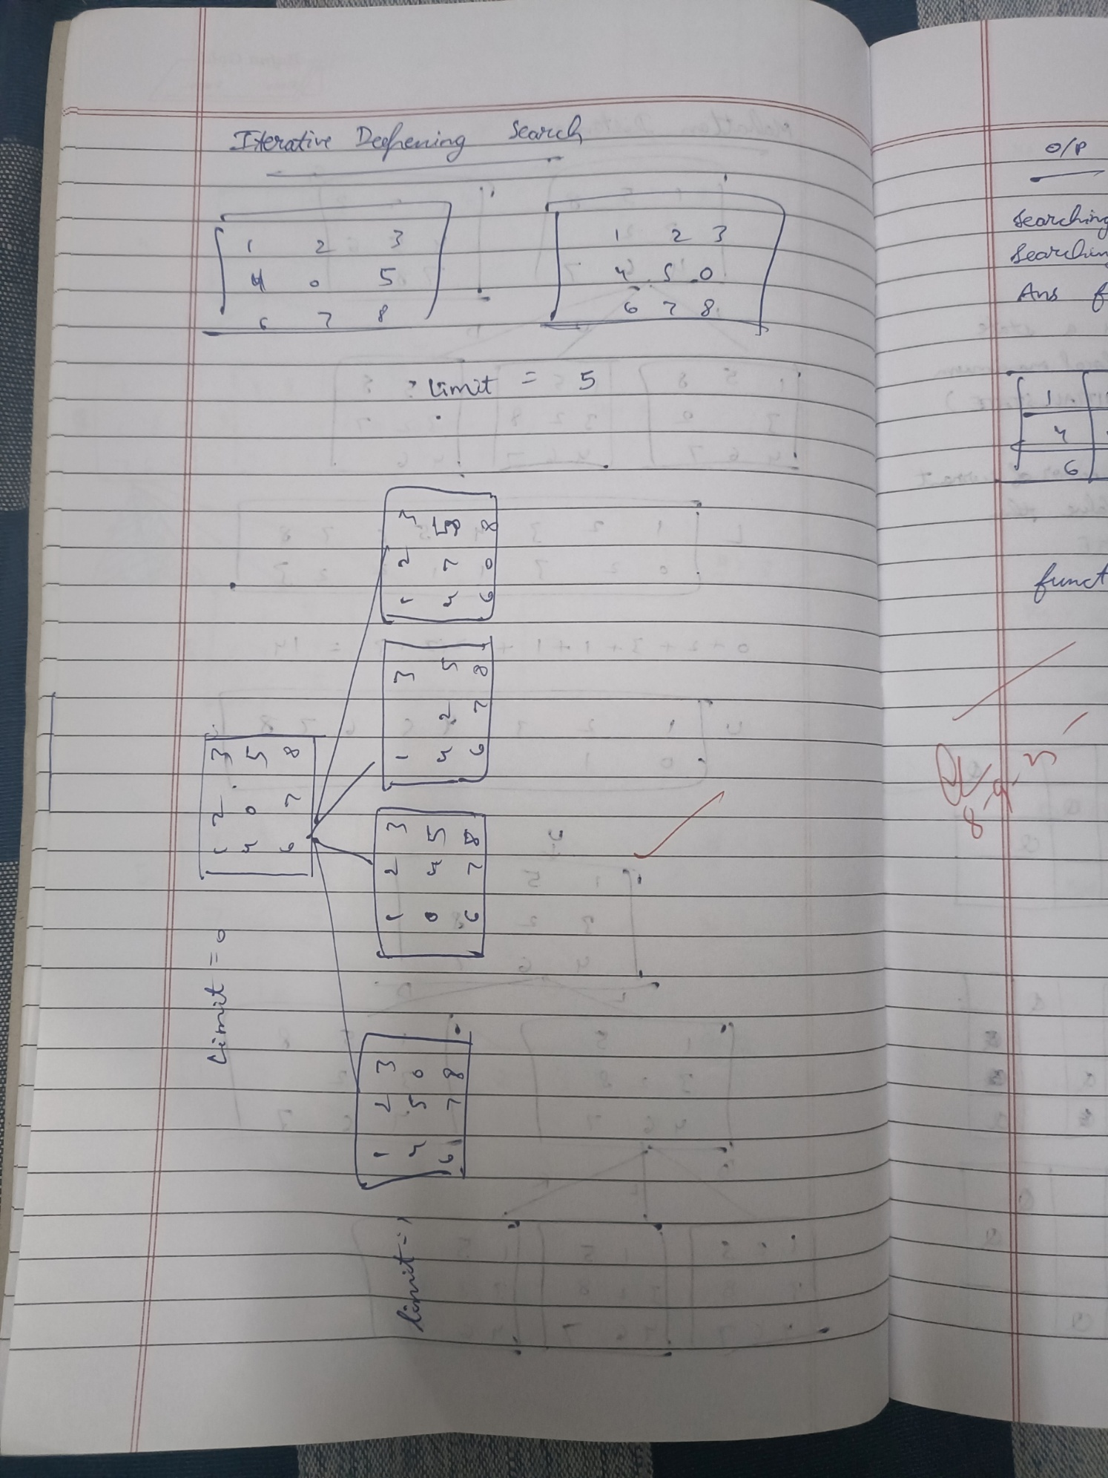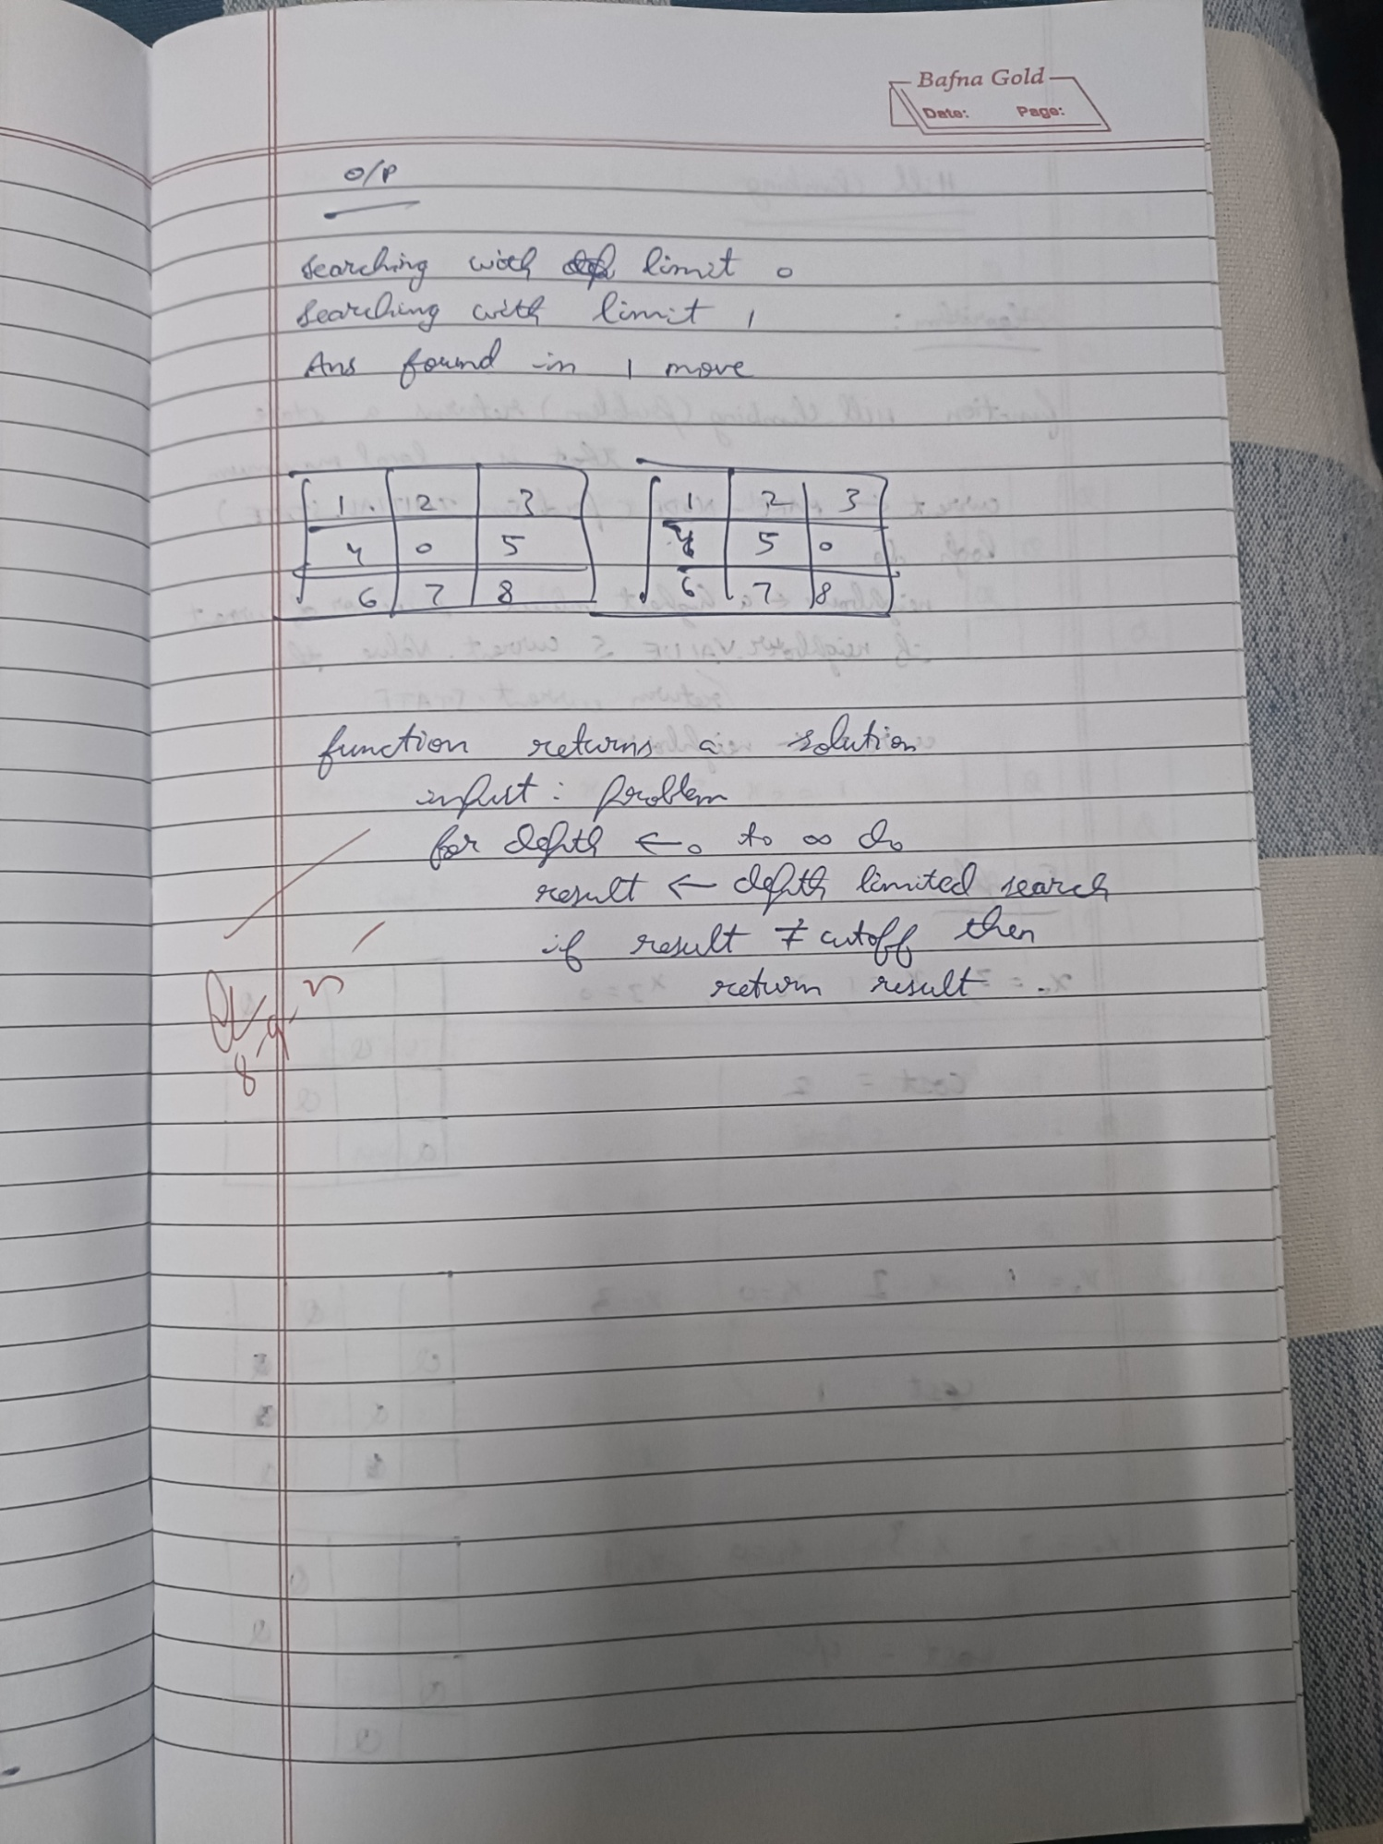

Code:

def find_blank(state):

    for i in range(3):

        for j in range(3):

            if state[i][j] == 0:

                return i, j

    return -1, -1

def generate_next_states(state):

    states = []

    i, j = find_blank(state)

    moves = [(0, 1), (0, -1), (1, 0), (-1, 0)]

    for move_i, move_j in moves:

        new_i, new_j = i + move_i, j + move_j

        if 0 <= new_i < 3 and 0 <= new_j < 3:

            new_state = [list(row) for row in state]

            new_state[i][j], new_state[new_i][new_j] = new_state[new_i][new_j], new_state[i][j]

            states.append(tuple(tuple(row) for row in new_state))

    return states

def solve_8_puzzle_dfs(initial_state, goal_state):

    initial_state_tuple = tuple(tuple(row) for row in initial_state)

    goal_state_tuple = tuple(tuple(row) for row in goal_state)

    stack = [(initial_state_tuple, [initial_state])]

    visited = set([initial_state_tuple])

    while stack:

        current_state_tuple, path = stack.pop()

        current_state = [list(row) for row in current_state_tuple]

        if current_state_tuple == goal_state_tuple:

            return path + [current_state]

        for next_state_tuple in generate_next_states(current_state):

            if next_state_tuple not in visited:

                visited.add(next_state_tuple)

                stack.append((next_state_tuple, path + [current_state]))

    return None

initial_state = [[1, 2, 3], [4, 0, 5], [6, 7, 8]]

goal_state = [[1, 2, 3], [4, 5, 6], [7, 8, 0]]

solution_path = solve_8_puzzle_dfs(initial_state, goal_state)

if solution_path:

    print("Solution found!")

    for i, state in enumerate(solution_path):

        print(f"Step {i+1}:")

        for row in state:

            print(row)

        print("-" * 10)

else:

    print("No solution found.")

def find_blank(state):

    for i in range(3):

        for j in range(3):

            if state[i][j] == 0:

                return i, j

    return -1, -1

def generate_next_states(state):

    states = []

    i, j = find_blank(state)

    moves = [(0, 1), (0, -1), (1, 0), (-1, 0)]

    for move_i, move_j in moves:

        new_i, new_j = i + move_i, j + move_j

        if 0 <= new_i < 3 and 0 <= new_j < 3:

            new_state = [list(row) for row in state]

            new_state[i][j], new_state[new_i][new_j] = new_state[new_i][new_j], new_state[i][j]

            states.append(tuple(tuple(row) for row in new_state))

    return states

def depth_limited_dfs(current_state, goal_state, limit, visited):

    current_state_tuple = tuple(tuple(row) for row in current_state)

    goal_state_tuple = tuple(tuple(row) for row in goal_state)

    if current_state_tuple == goal_state_tuple:

        return [current_state]

    if limit <= 0:

        return None

    for next_state_tuple in generate_next_states(current_state):

        if next_state_tuple not in visited:

            visited.add(next_state_tuple)

            next_state = [list(row) for row in next_state_tuple]

            result = depth_limited_dfs(next_state, goal_state, limit - 1, visited)

            if result:

                return [current_state] + result

            visited.remove(next_state_tuple)

    return None

def solve_8_puzzle_iddfs(initial_state, goal_state, max_depth):

    for limit in range(max_depth + 1):

        visited = set()

        solution = depth_limited_dfs(initial_state, goal_state, limit, visited)

        if solution:

            return solution

    return None

initial_state = [[1, 2, 3], [4, 0, 5], [6, 7, 8]]

goal_state = [[1, 2, 3], [4, 5, 6], [7, 8, 0]]

max_depth = 20

solution_path = solve_8_puzzle_iddfs(initial_state, goal_state, max_depth)

if solution_path:

    print("Solution found!")

    for i, state in enumerate(solution_path):

        print(f"Step {i+1}:")

        for row in state:

            print(row)

        print("-" * 10)

else:

    print(f"No solution found within maximum depth of {max_depth}.")

**Program 3**

Implement A* search algorithm

Algorithm:

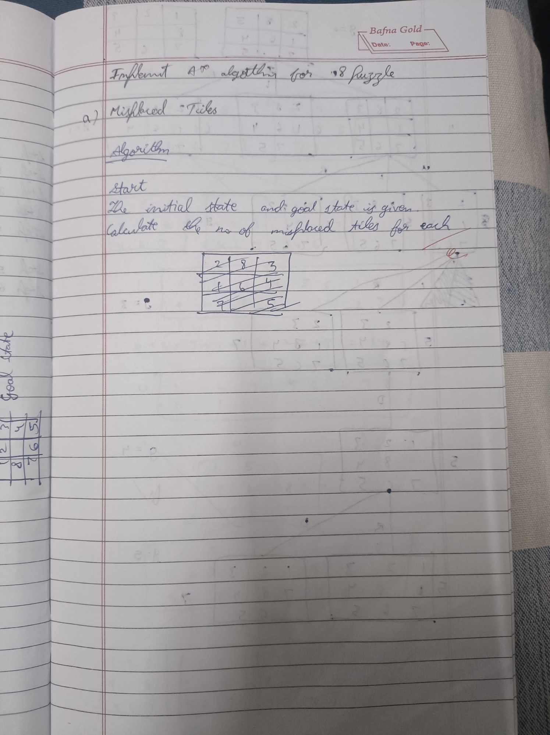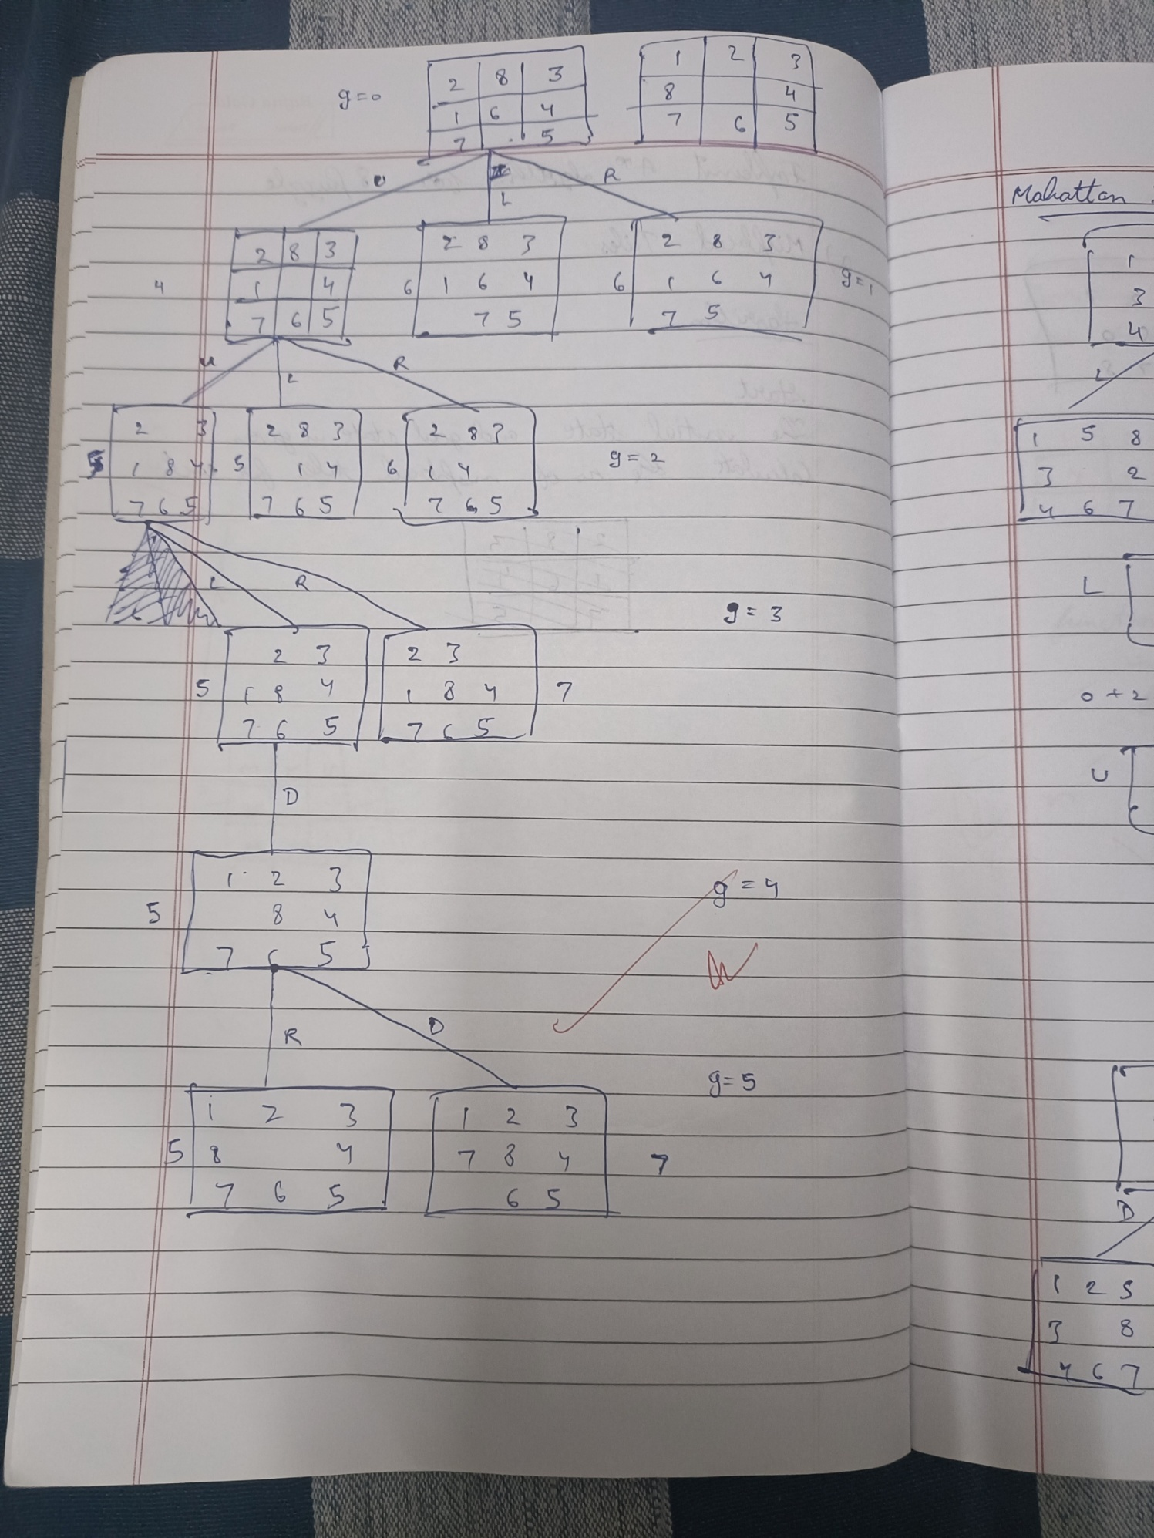

Code:

import heapq

def find_blank(state):

    for i in range(3):

        for j in range(3):

            if state[i][j] == 0:

                return i, j

    return -1, -1

def generate_next_states(state):

    states = []

    i, j = find_blank(state)

    moves = [(0, 1), (0, -1), (1, 0), (-1, 0)]

    for move_i, move_j in moves:

        new_i, new_j = i + move_i, j + move_j

        if 0 <= new_i < 3 and 0 <= new_j < 3:

            new_state = [list(row) for row in state]

            new_state[i][j], new_state[new_i][new_j] = new_state[new_i][new_j], new_state[i][j]

            states.append(tuple(tuple(row) for row in new_state))

    return states

def manhattan_distance_heuristic(state, goal_state):

    distance = 0

    for i in range(3):

        for j in range(3):

            tile = state[i][j]

            if tile != 0:

                goal_i, goal_j = -1, -1

                for row_idx in range(3):

                    for col_idx in range(3):

                        if goal_state[row_idx][col_idx] == tile:

                            goal_i, goal_j = row_idx, col_idx

                            break

                    if goal_i != -1:

                        break

                distance += abs(i - goal_i) + abs(j - goal_j)

    return distance

def solve_8_puzzle_astar_manhattan(initial_state, goal_state):

    initial_state_tuple = tuple(tuple(row) for row in initial_state)

    goal_state_list = [list(row) for row in goal_state]

    priority_queue = [(manhattan_distance_heuristic(initial_state, goal_state_list), 0, initial_state_tuple, [initial_state])]

    visited = set([initial_state_tuple])

    while priority_queue:

        f_cost, g_cost, current_state_tuple, path = heapq.heappop(priority_queue)

        current_state = [list(row) for row in current_state_tuple]

        if current_state == goal_state_list:

            return path + [current_state]

        for next_state_tuple in generate_next_states(current_state):

            if next_state_tuple not in visited:

                visited.add(next_state_tuple)

                next_state = [list(row) for row in next_state_tuple]

                next_g_cost = g_cost + 1

                next_h_cost = manhattan_distance_heuristic(next_state, goal_state_list)

                next_f_cost = next_g_cost + next_h_cost

                heapq.heappush(priority_queue, (next_f_cost, next_g_cost, next_state_tuple, path + [current_state]))

    return None

initial_state = [[1, 2, 3], [4, 0, 5], [6, 7, 8]]

goal_state = [[1, 2, 3], [4, 5, 6], [7, 8, 0]]

solution_path = solve_8_puzzle_astar_manhattan(initial_state, goal_state)

if solution_path:

    print("Solution found!")

    for i, state in enumerate(solution_path):

        print(f"Step {i+1}:")

        for row in state:

            print(row)

        print("-" * 10)

else:

    print("No solution found.")

**Program 4**

Implement Hill Climbing search algorithm to solve N-Queens problem

Algorithm:

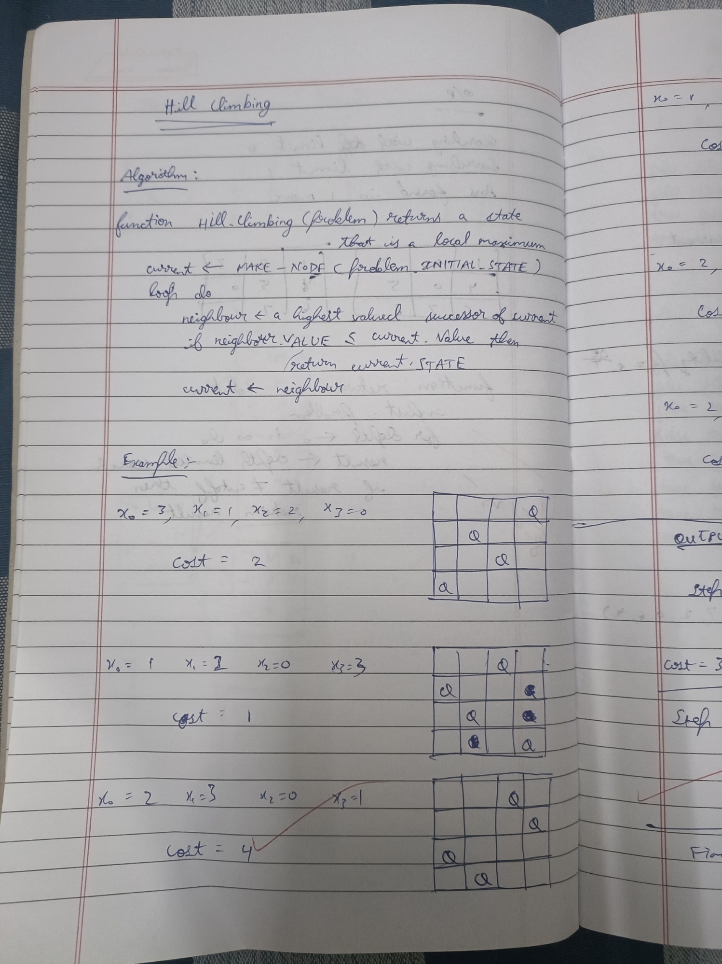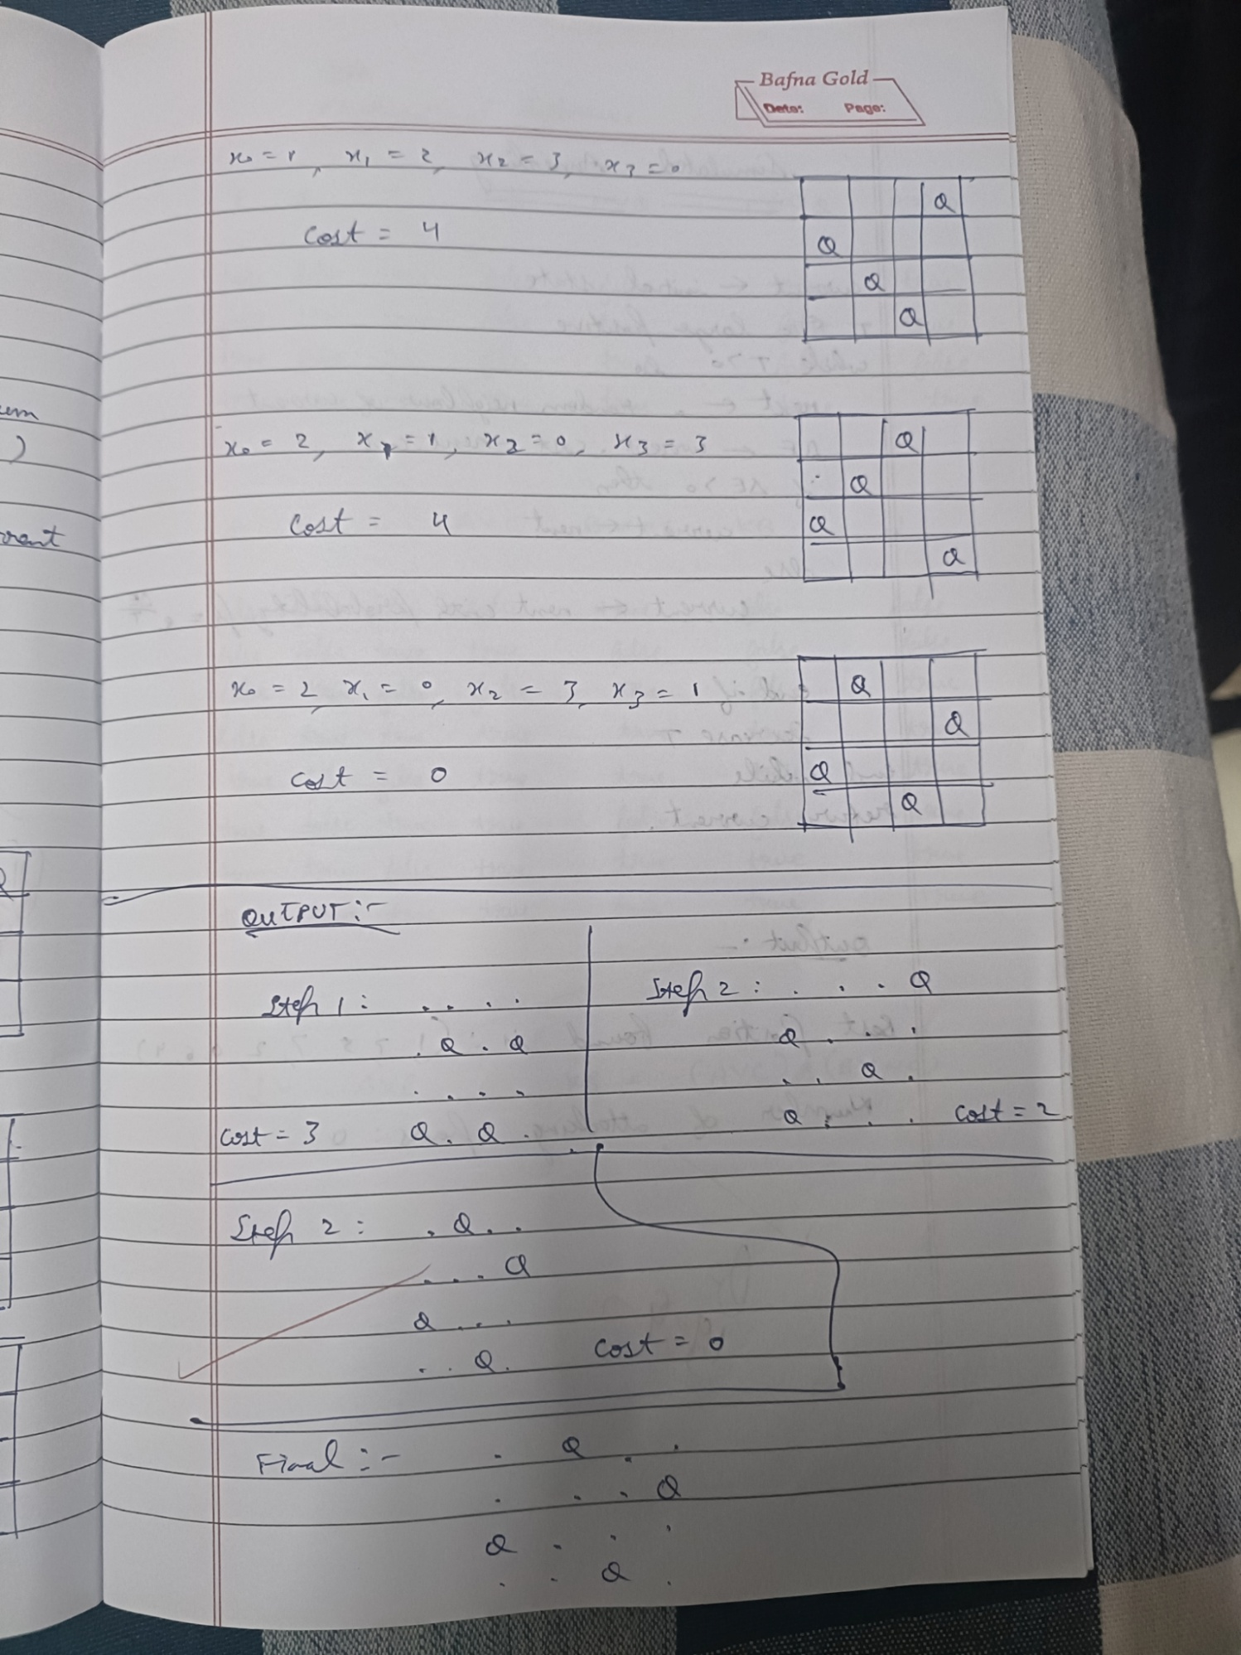

Code:

import random

def cost(state):

    attacking_pairs = 0

    n = len(state)

    for i in range(n):

        for j in range(i + 1, n):

            if state[i] == state[j] or abs(state[i] - state[j]) == abs(i - j):

                attacking_pairs += 1

    return attacking_pairs

def print_board(state):

    n = len(state)

    board = [['.' for _ in range(n)] for _ in range(n)]

    for i in range(n):

        board[state[i]][i] = 'Q'

    for row in board:

        print(" ".join(row))

def get_neighbors(state):

    neighbors = []

    n = len(state)

    for i in range(n):

        for j in range(i + 1, n):

            neighbor = list(state)

            neighbor[i], neighbor[j] = neighbor[j], neighbor[i]

            neighbors.append(tuple(neighbor))

    return neighbors

def hill_climbing(initial_state):

    current = initial_state

    print(f"Initial state:")

    print_board(current)

    print(f"Cost: {cost(current)}")

    print('-' * 20)

    while True:

        neighbors = get_neighbors(current)

        next_state = min(neighbors, key=lambda x: cost(x))

        print(f"Next state:")

        print_board(next_state)

        print(f"Cost: {cost(next_state)}")

        print('-' * 20)

        if cost(next_state) >= cost(current):

            print(f"Solution found:")

            print_board(current)

            print(f"Cost: {cost(current)}")

            return current

        current = next_state

if __name__ == "__main__":

    initial_state = (3, 1, 2, 0)

    solution = hill_climbing(initial_state)

**Program 5**

Simulated Annealing to Solve 8-Queens problem

Algorithm:

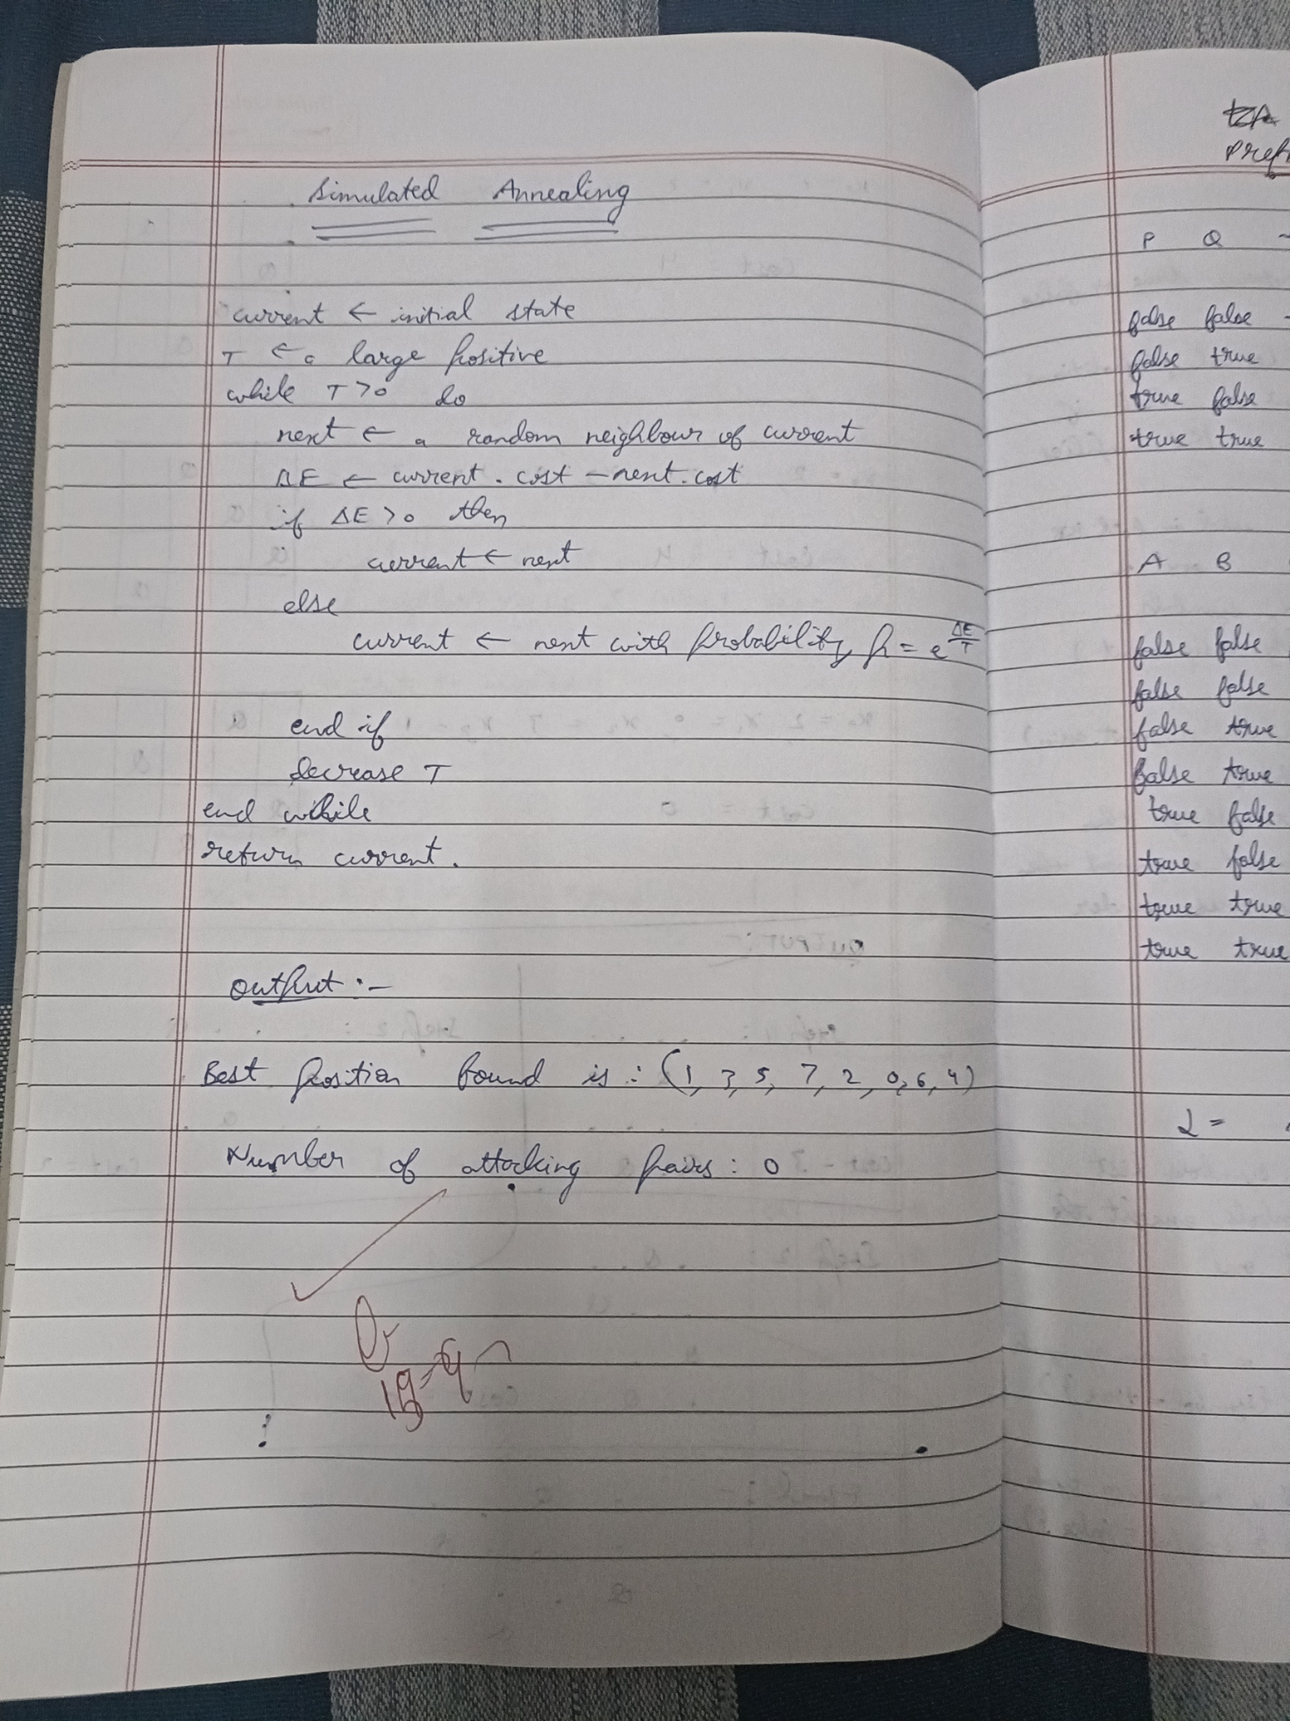

Code:

import math

import random

def cost(state):

    attacking_pairs = 0

    n = len(state)

    for i in range(n):

        for j in range(i+1, n):

            if state[i] == state[j] or abs(state[i] - state[j]) == abs(i - j):

                attacking_pairs += 1

    return attacking_pairs

def random_neighbor(state):

    n = len(state)

    neighbor = list(state)

    i, j = random.sample(range(n), 2)

    neighbor[i], neighbor[j] = neighbor[j], neighbor[i]

    return tuple(neighbor)

def simulated_annealing(initial_state, initial_temp, cooling_rate, max_iter):

    current = initial_state

    T = initial_temp

    for _ in range(max_iter):

        if T <= 0:

            break

        next_state = random_neighbor(current)

        delta_E = cost(current) - cost(next_state)

        if delta_E > 0:

            current = next_state

        else:

            probability = math.exp(delta_E / T)

            if random.random() < probability:

                current = next_state

        T *= cooling_rate

    return current

if __name__ == "__main__":

    n = 8

    initial_state = tuple(random.sample(range(n), n))

    initial_temp = 1000.0

    cooling_rate = 0.95

    max_iter = 10000

    solution = simulated_annealing(initial_state, initial_temp, cooling_rate, max_iter)

    print("Best position found is:", solution)

    print("Number of attacking pairs:", cost(solution))

**Program 6**

Create a knowledge base using propositional logic and show that the given query entails the knowledge base or not.

Algorithm:

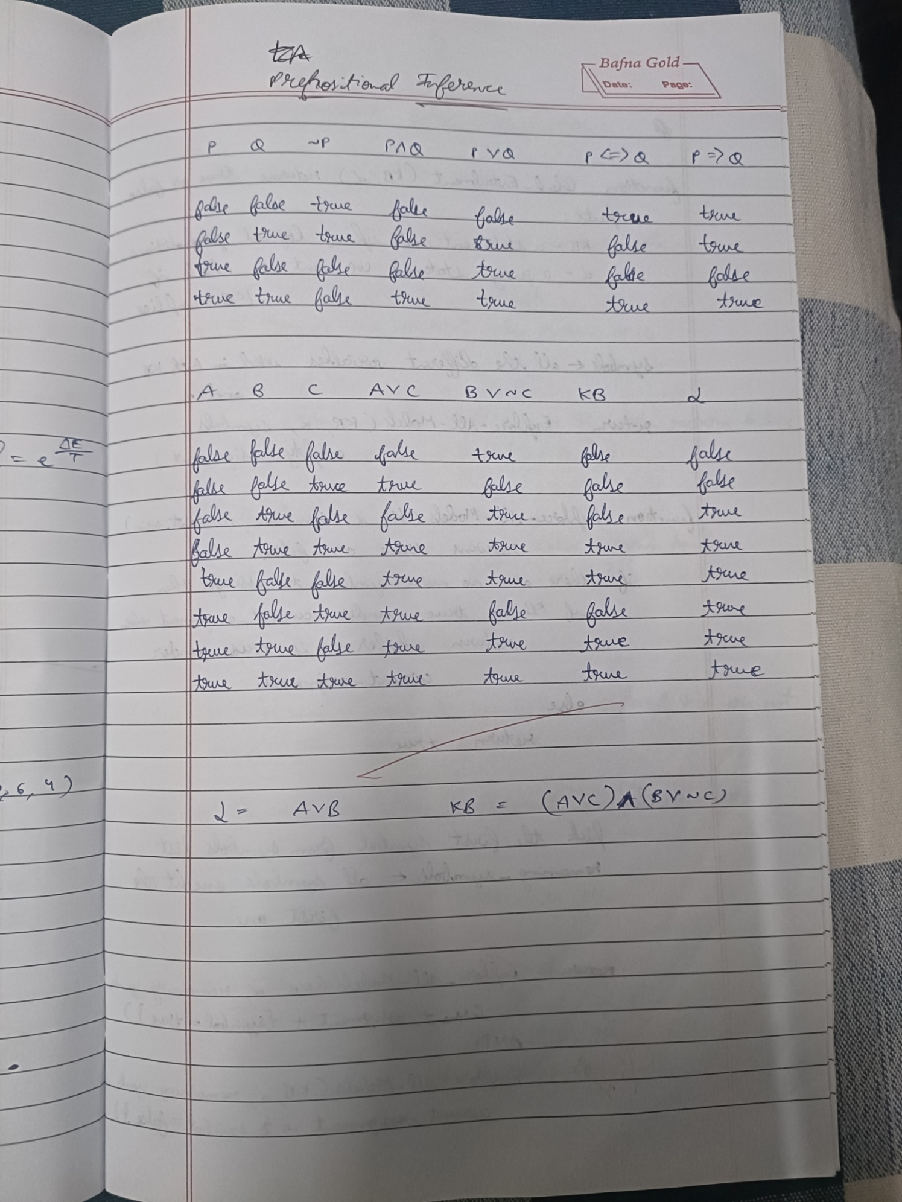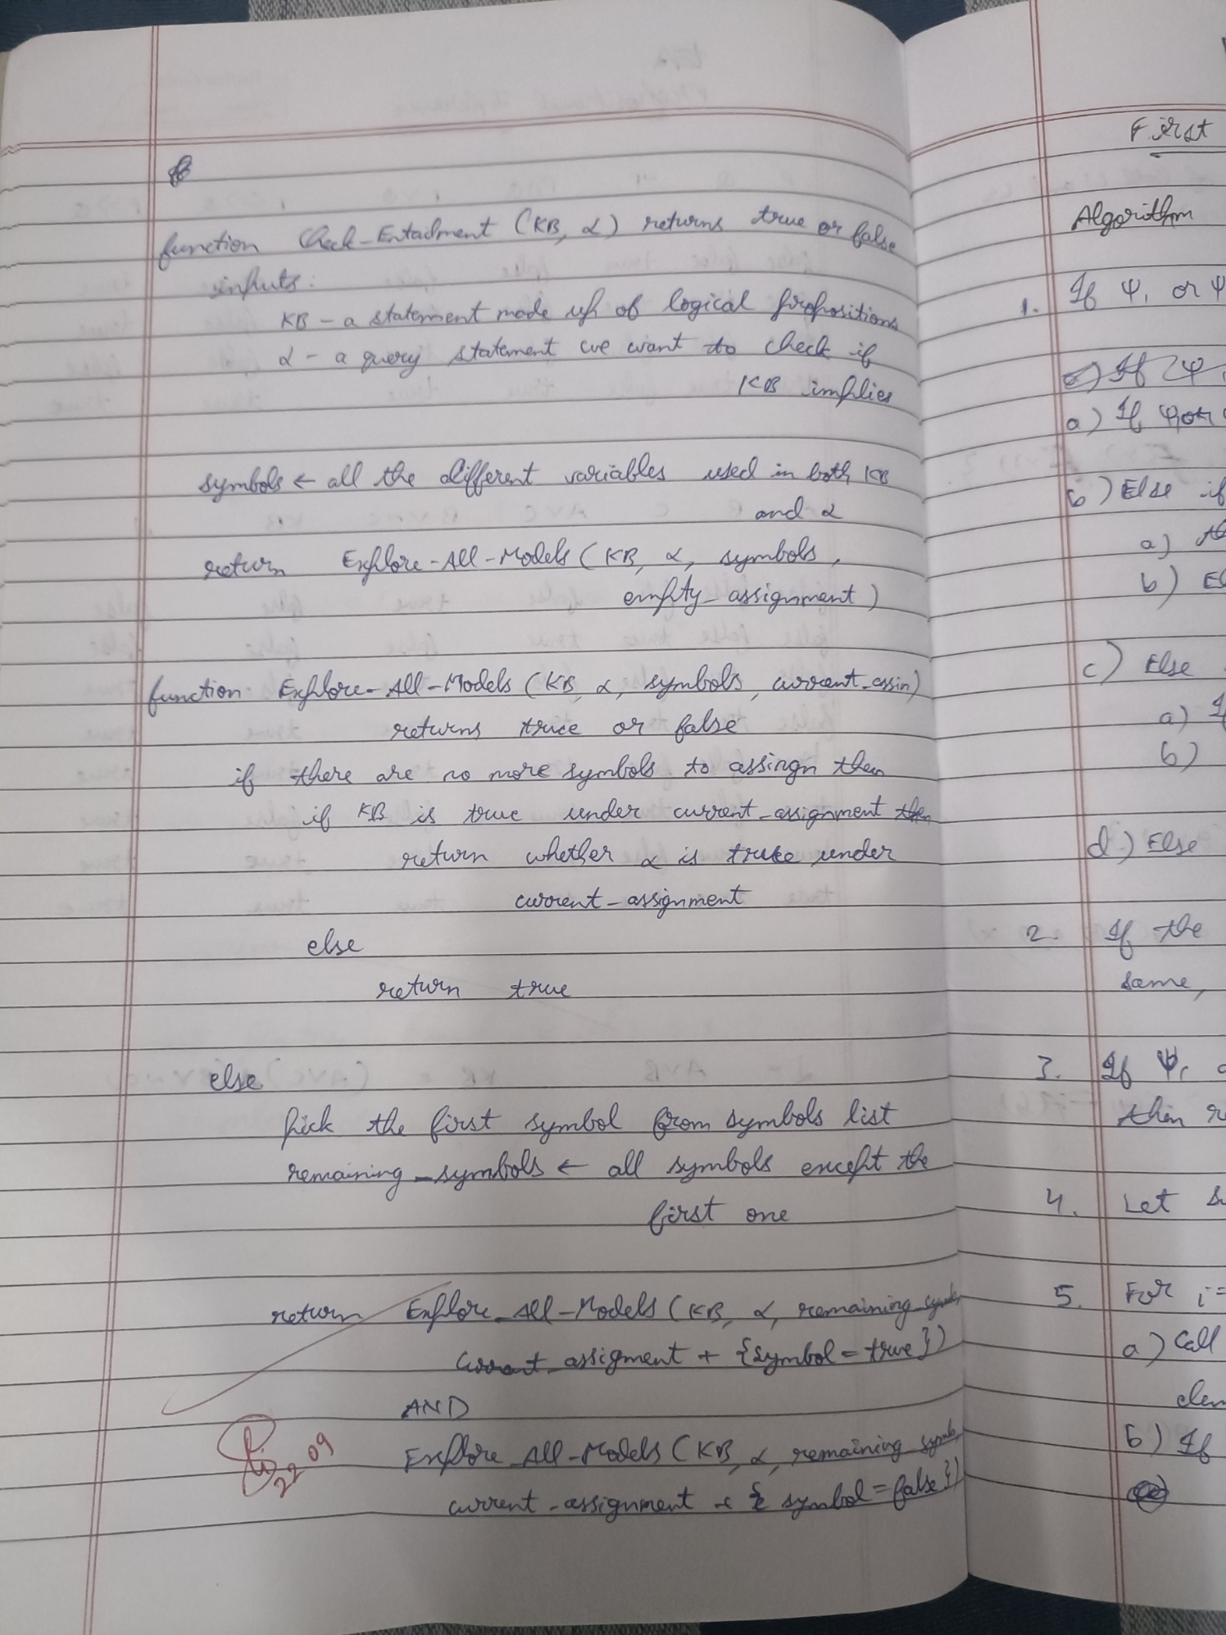

Code:

import pandas as pd

from itertools import product

import re

def tokenize(sentence):

    token_pattern = r'\w+|[()]'

    return re.findall(token_pattern, sentence)

def pl_true(sentence, model):

    tokens = tokenize(sentence)

    logical_ops = {'and', 'or', 'not'}

    evaluated_tokens = []

    for token in tokens:

        token_lower = token.lower()

        if token_lower in logical_ops:

            evaluated_tokens.append(token_lower)

        elif token in model:

            evaluated_tokens.append(str(model[token]))

        else:

            evaluated_tokens.append(token)

    eval_sentence = ' '.join(evaluated_tokens)

    try:

        return eval(eval_sentence)

    except Exception as e:

        print(f"Error evaluating sentence: {eval_sentence}")

        raise e

def tt_entails(kb, alpha, symbols):

    truth_table = []

    for model in product([False, True], repeat=len(symbols)):

        model_dict = dict(zip(symbols, model))

        kb_value = pl_true(kb, model_dict)

        alpha_value = pl_true(alpha, model_dict)

        row = {

            'A': model_dict.get('A', False),

            'B': model_dict.get('B', False),

            'C': model_dict.get('C', False),

            'A or C': model_dict.get('A', False) or model_dict.get('C', False),

            'B or not C': model_dict.get('B', False) or not model_dict.get('C', False),

            'KB': kb_value,

            'α': alpha_value

        }

        truth_table.append(row)

        if kb_value and not alpha_value:

            return False, pd.DataFrame(truth_table)

    return True, pd.DataFrame(truth_table)

def get_symbols(kb, alpha):

    return sorted(set(re.findall(r'[A-Z]', kb + alpha)))

kb = "(A or C) and (B or not C)"

alpha = "A or B"

symbols = get_symbols(kb, alpha)

result, truth_table = tt_entails(kb, alpha, symbols)

print("Truth Table:")

display(truth_table)

if result:

    print("\nKB entails α")

else:

    print("\nKB does not entail α")

**Program 7**

Implement unification in first order logic

Algorithm:

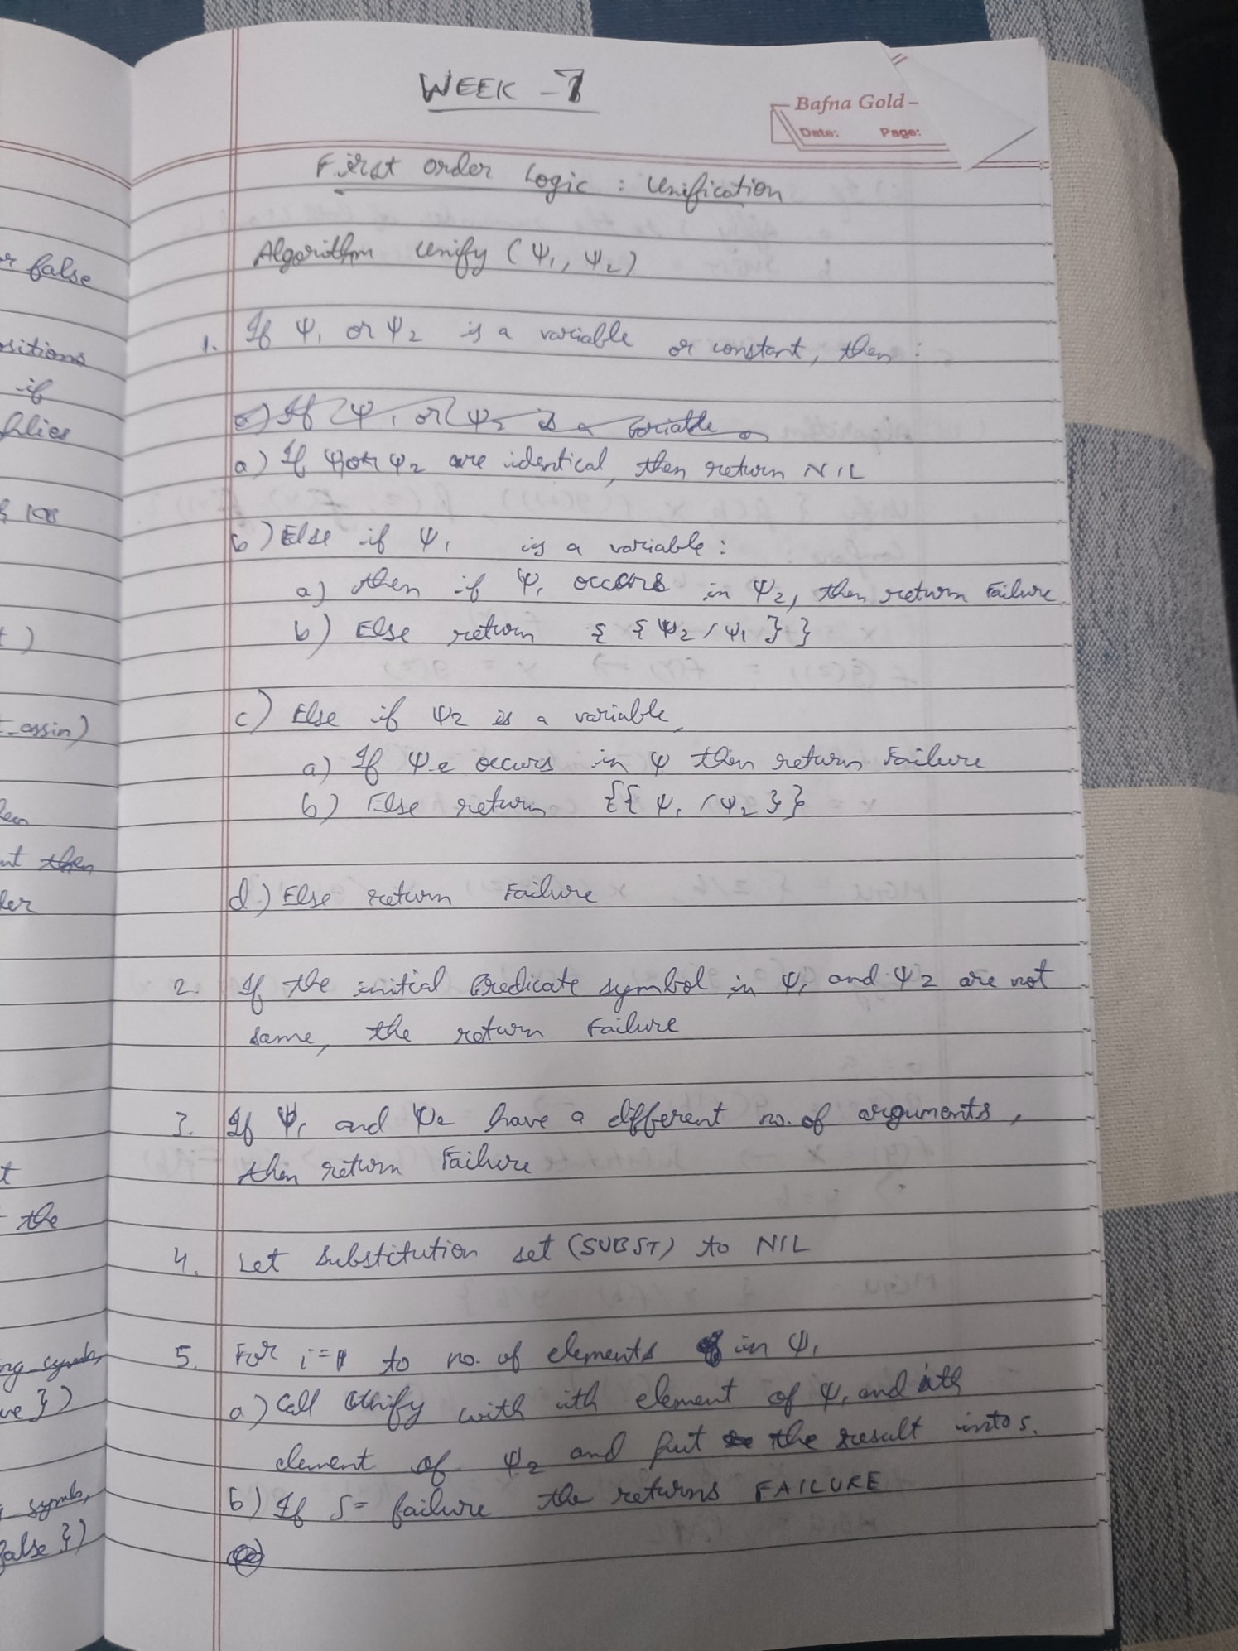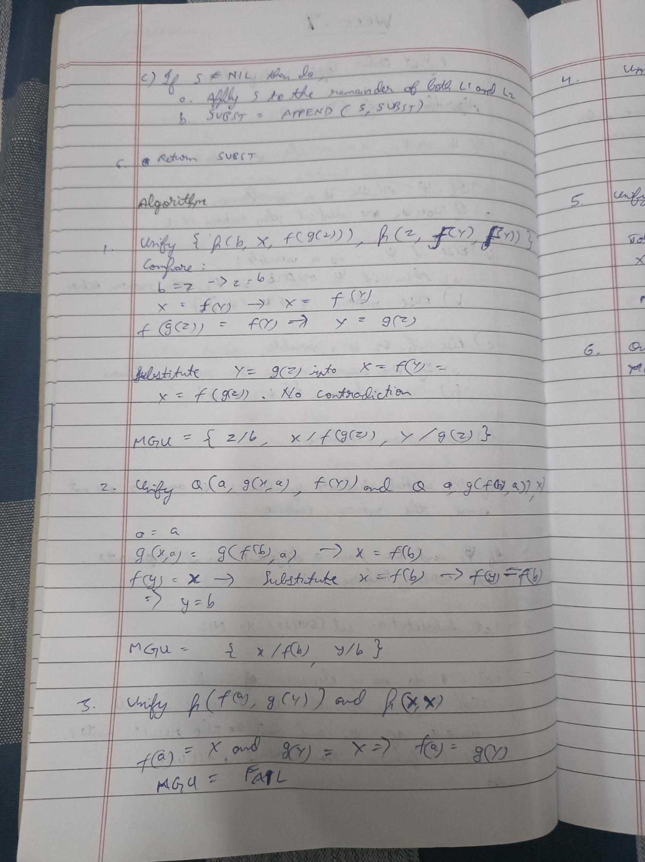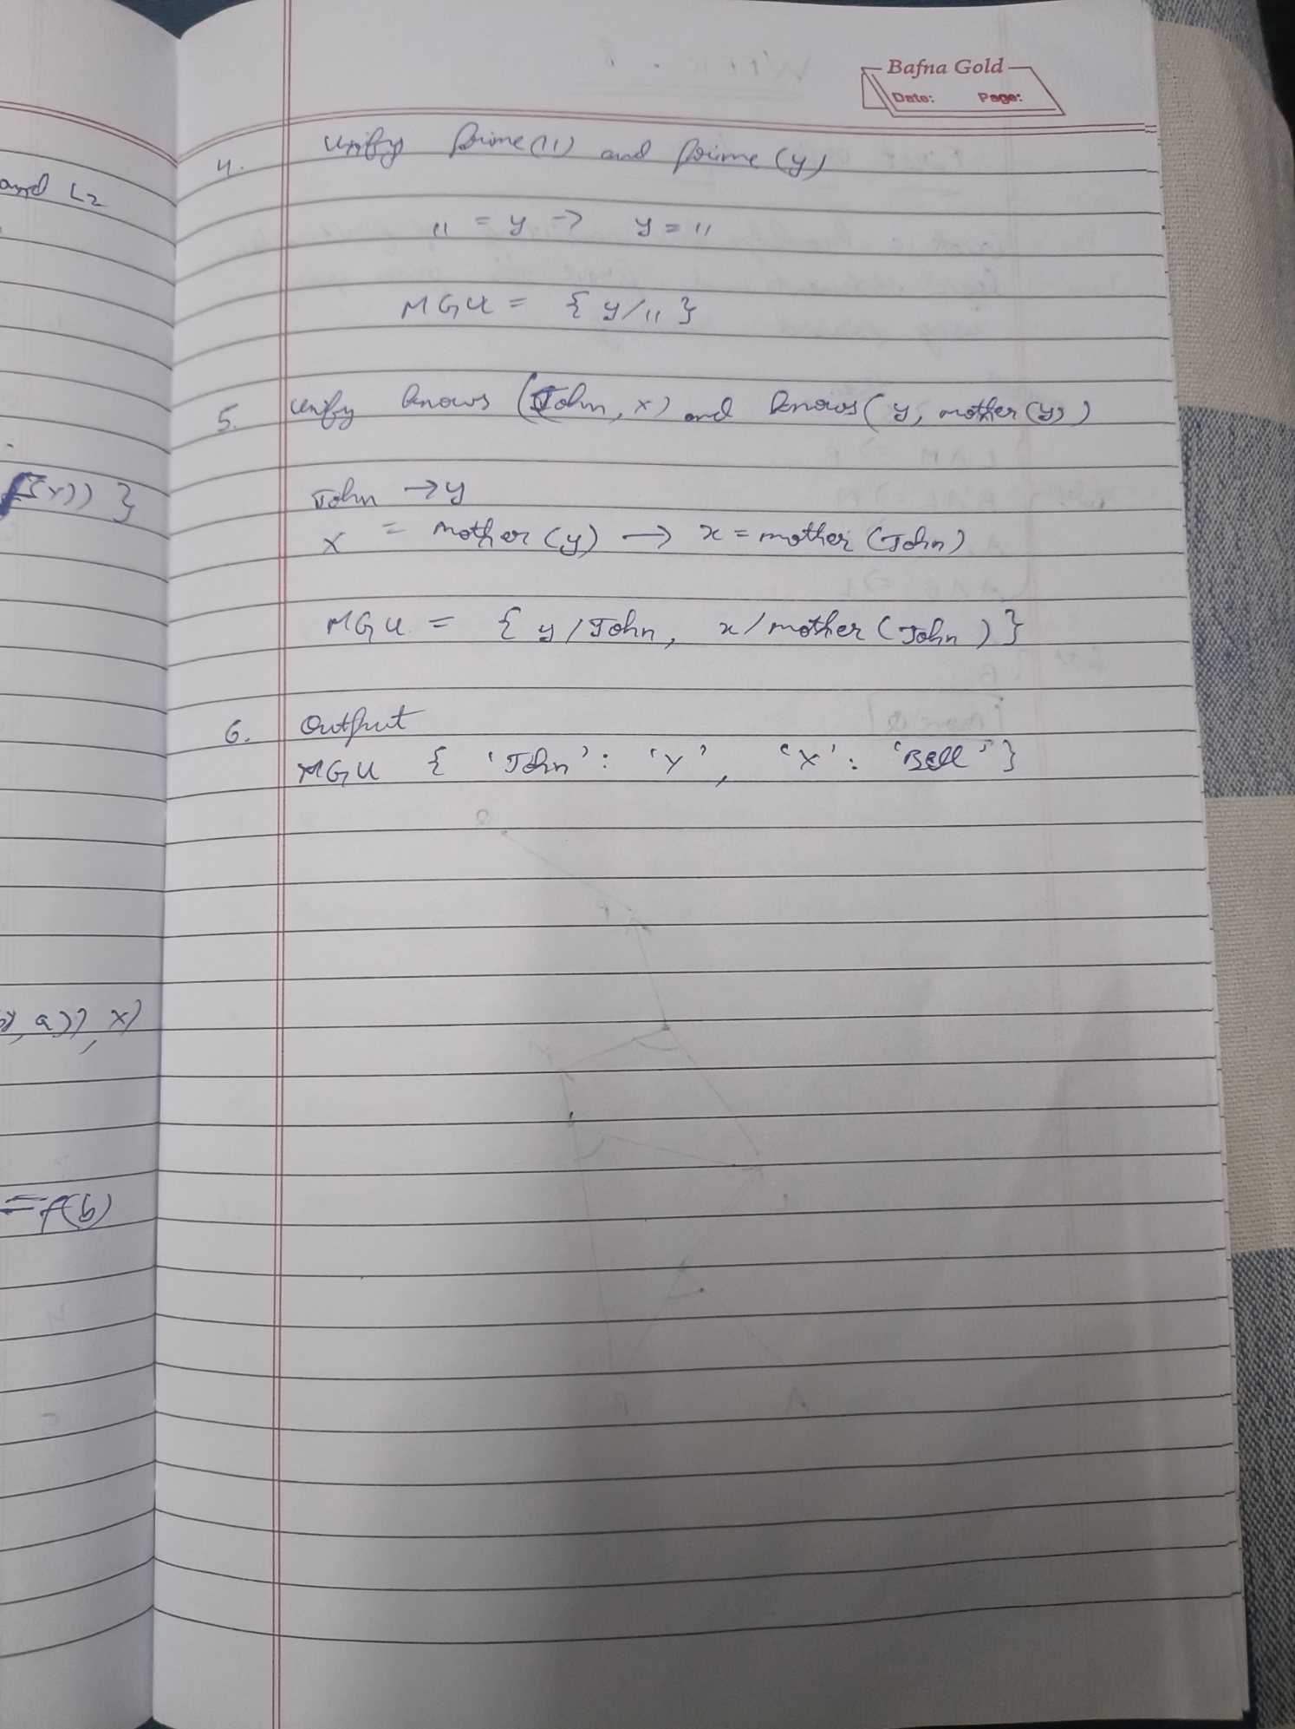

Code:

# --- Unification in First Order Logic ---

# Author: Based on standard AI unification algorithm

def is_variable(x):

    """Check if x is a variable (lowercase string)."""

    return isinstance(x, str) and x.islower()

def unify_var(var, x, subst):

    """Unify variable with a term, updating substitution."""

    if var in subst:

        return unify(subst[var], x, subst)

    elif is_variable(x) and x in subst:

        return unify(var, subst[x], subst)

    elif occurs_check(var, x, subst):

        return None

    else:

        subst[var] = x

        return subst

def occurs_check(var, x, subst):

    """Ensure variable does not occur in x (to prevent infinite loop)."""

    if var == x:

        return True

    elif isinstance(x, list):

        return any(occurs_check(var, xi, subst) for xi in x)

    elif x in subst:

        return occurs_check(var, subst[x], subst)

    return False

def unify(x, y, subst=None):

    """Main Unify function."""

    if subst is None:

        subst = {}

    if subst is None:

        return None

    elif x == y:

        return subst

    elif is_variable(x):

        return unify_var(x, y, subst)

    elif is_variable(y):

        return unify_var(y, x, subst)

    elif isinstance(x, list) and isinstance(y, list) and len(x) == len(y):

        for xi, yi in zip(x, y):

            subst = unify(xi, yi, subst)

            if subst is None:

                return None

        return subst

    elif isinstance(x, tuple) and isinstance(y, tuple) and x[0] == y[0]:

        # Predicate/function unification

        return unify(list(x[1:]), list(y[1:]), subst)

    else:

        return None

# --- Example Usage ---

# Unifying Eats(x, Apple) with Eats(Riya, y)

expr1 = ('Eats', 'x', 'Apple')

expr2 = ('Eats', 'Riya', 'y')

result = unify(expr1, expr2)

if result is None:

    print("Unification failed.")

else:

    print("Unification successful.")

    print("Substitutions:", result)

**Program 8**

Create a knowledge base consisting of first order logic statements and prove the given query using forward reasoning.

Algorithm:

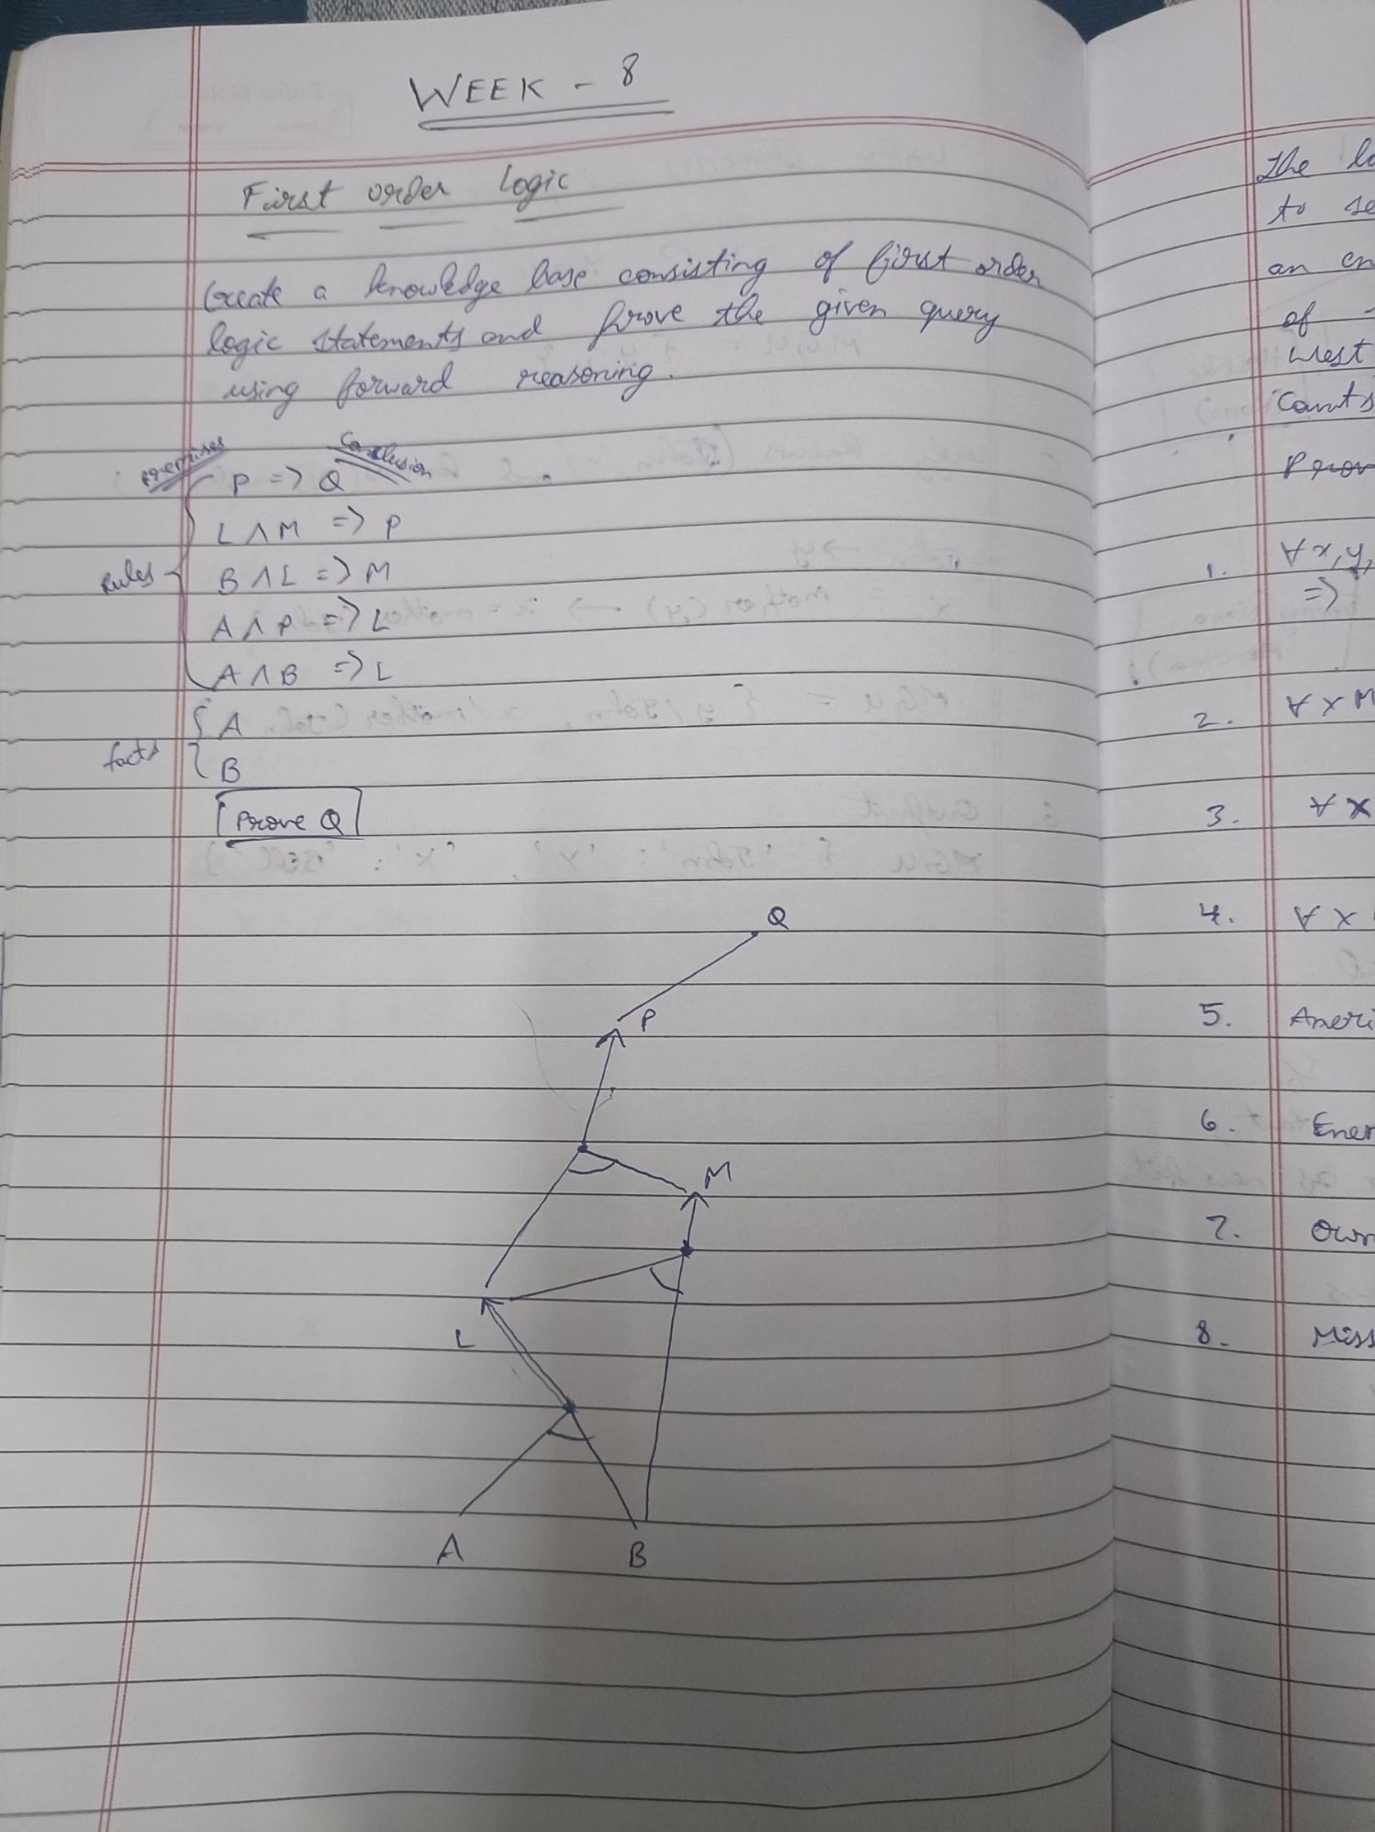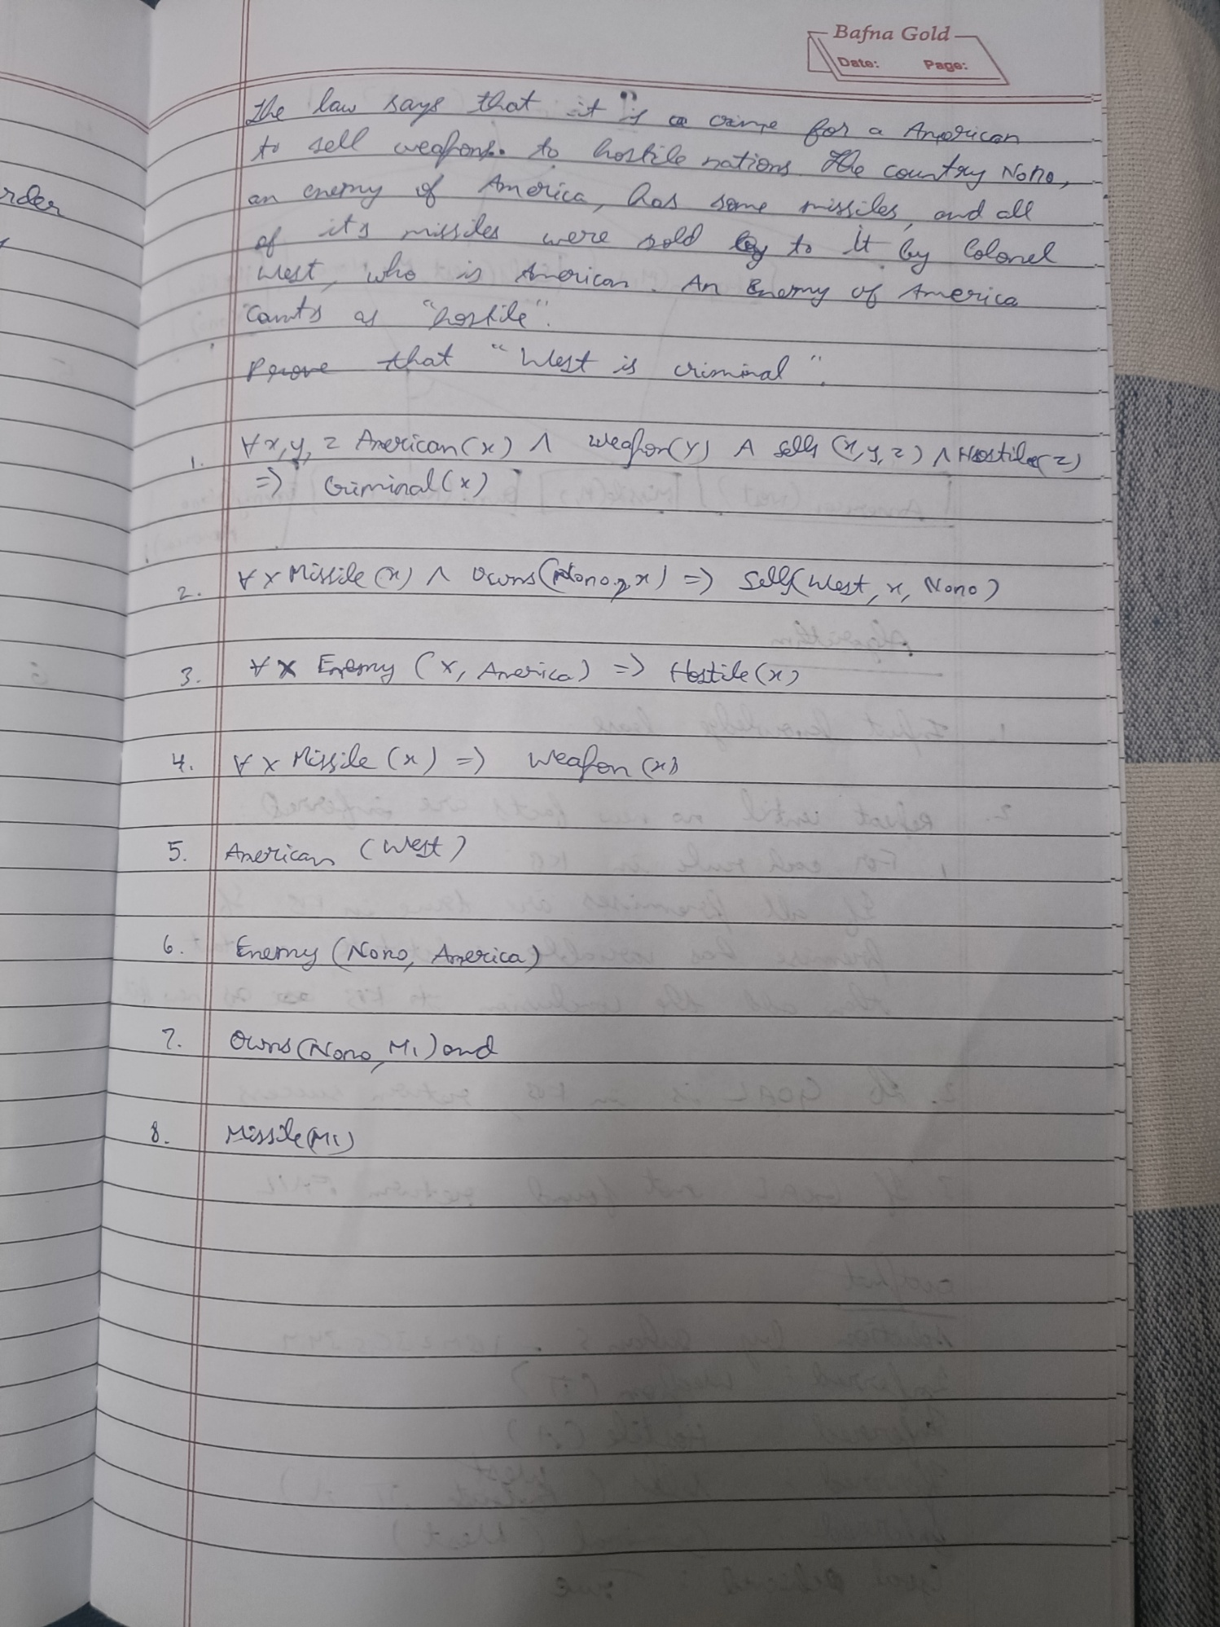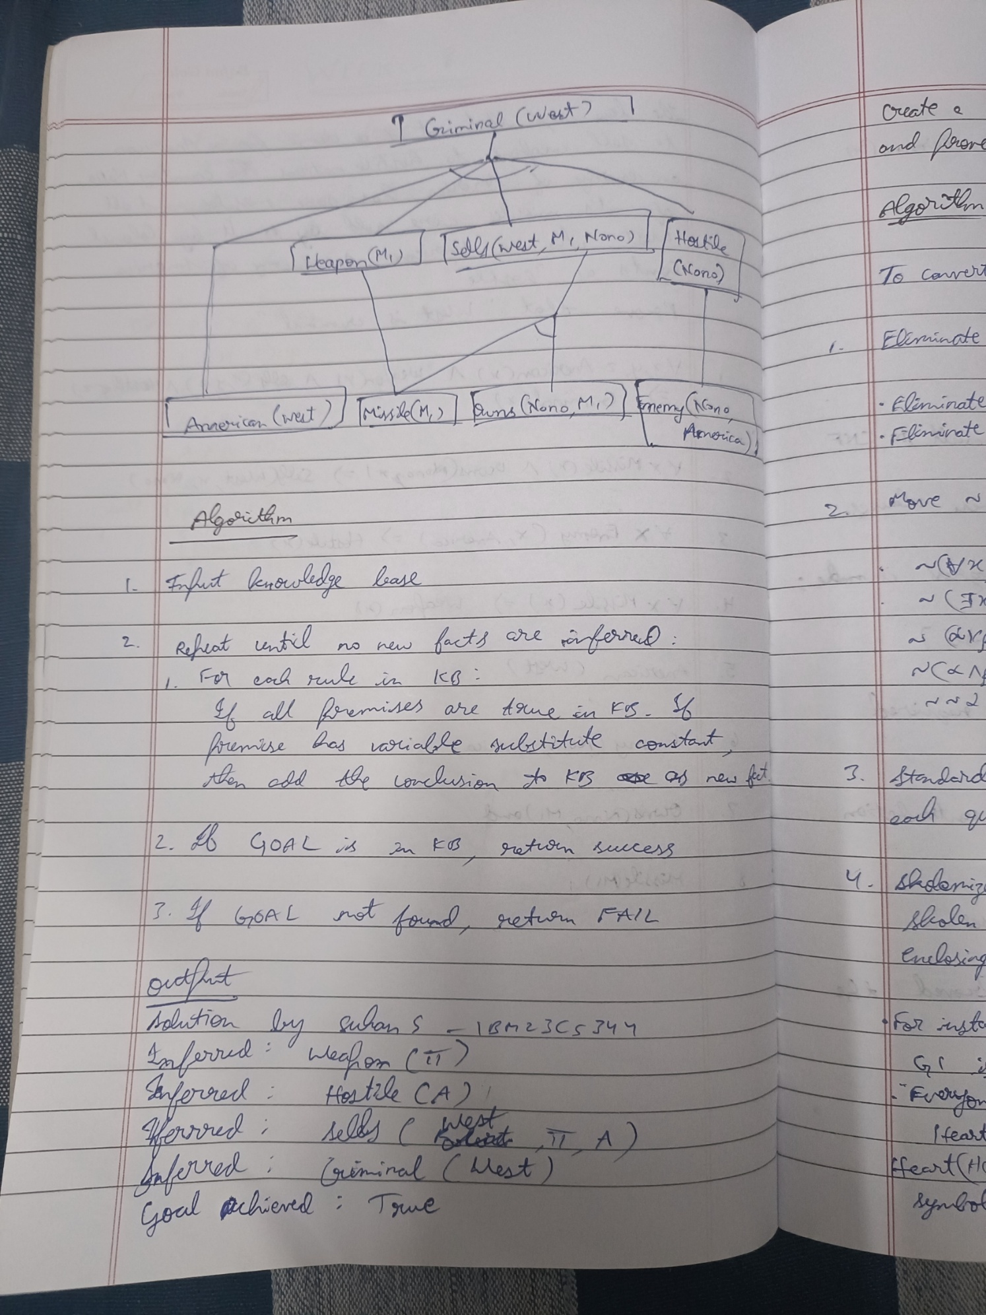

Code:

# --- Forward Chaining in First Order Logic ---

# Problem: Prove "Robert is a criminal" using given knowledge base and rules

# Knowledge Base representation

knowledge_base = [

    # Rule: If an American sells weapons to a hostile country -> criminal

    {

        "if": ["American(x)", "Weapon(y)", "Sells(x, y, z)", "Hostile(z)"],

        "then": "Criminal(x)"

    },

    # Facts

    "Owns(A, T1)",

    "Missile(T1)",

    "American(Robert)",

    "Enemy(A, America)",

    # Rules

    {

        "if": ["Missile(x)"],

        "then": "Weapon(x)"

    },

    {

        "if": ["Enemy(x, America)"],

        "then": "Hostile(x)"

    },

    {

        "if": ["Missile(y)", "Owns(A, y)"],

        "then": "Sells(Robert, y, A)"

    }

]

# --- Helper Functions ---

def is_variable(x):

    """Check if a term is a variable (lowercase)."""

    return isinstance(x, str) and x[0].islower()

def match(pattern, fact):

    """Match pattern like 'American(x)' with fact like 'American(Robert)'."""

    pattern_name, pattern_args = parse_predicate(pattern)

    fact_name, fact_args = parse_predicate(fact)

    if pattern_name != fact_name or len(pattern_args) != len(fact_args):

        return None

    subst = {}

    for p, f in zip(pattern_args, fact_args):

        if is_variable(p):

            subst[p] = f

        elif p != f:

            return None

    return subst

def substitute(expr, subst):

    """Apply substitution to a predicate expression."""

    name, args = parse_predicate(expr)

    new_args = [subst.get(arg, arg) for arg in args]

    return f"{name}({', '.join(new_args)})"

def parse_predicate(expr):

    """Parse 'Predicate(arg1, arg2)' -> ('Predicate', ['arg1', 'arg2'])"""

    name = expr.split("(")[0]

    args = expr.split("(")[1].rstrip(")").split(", ")

    return name, args

# --- Forward Chaining Algorithm ---

def forward_chaining(KB, query):

    """Implements FOL Forward Chaining."""

    inferred = set()

    facts = set([x for x in KB if isinstance(x, str)])

    rules = [x for x in KB if isinstance(x, dict)]

    print("Initial facts:", facts)

    while True:

        new_facts = set()

        for rule in rules:

            conditions = rule["if"]

            conclusion = rule["then"]

            # Try to find substitutions for each condition

            possible_subst = [{}]

            for cond in conditions:

                new_possible_subst = []

                for subst in possible_subst:

                    cond_sub = substitute(cond, subst)

                    for fact in facts:

                        match_subst = match(cond_sub, fact)

                        if match_subst is not None:

                            combined = {**subst, **match_subst}

                            new_possible_subst.append(combined)

                possible_subst = new_possible_subst

            for subst in possible_subst:

                new_fact = substitute(conclusion, subst)

                if new_fact not in facts and new_fact not in new_facts:

                    print(f"Inferred new fact: {new_fact}")

                    new_facts.add(new_fact)

                    if new_fact == query:

                        print("\n✅ Query proven using Forward Chaining!")

                        return True

        if not new_facts:

            break

        facts.update(new_facts)

    print("\n❌ Query could not be proven using Forward Chaining.")

    return False

# --- Run Forward Chaining ---

query = "Criminal(Robert)"

print("Proving query:", query)

forward_chaining(knowledge_base, query)

**Program 9**

Create a knowledge base consisting of first order logic statements and prove the given query using Resolution

Algorithm:

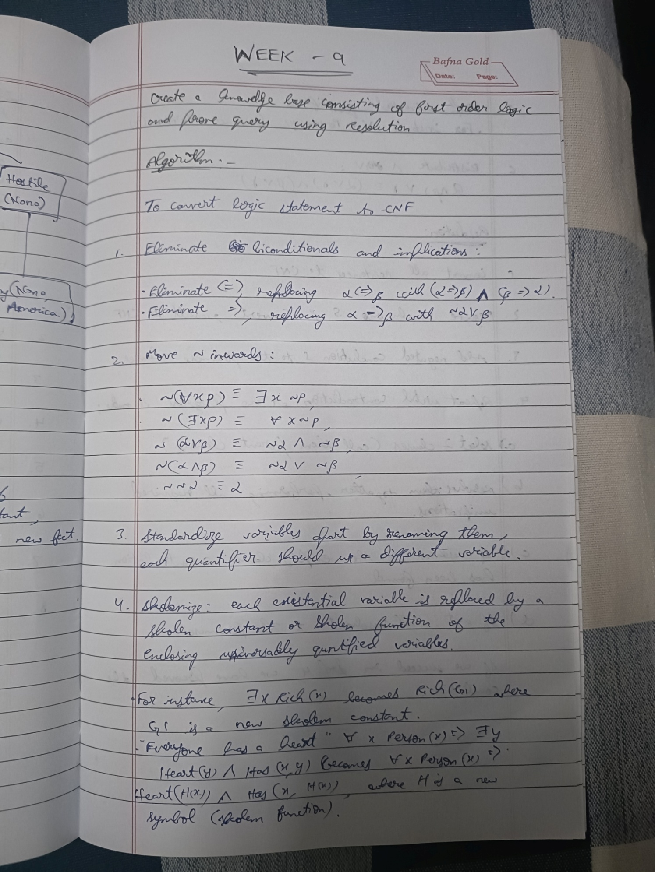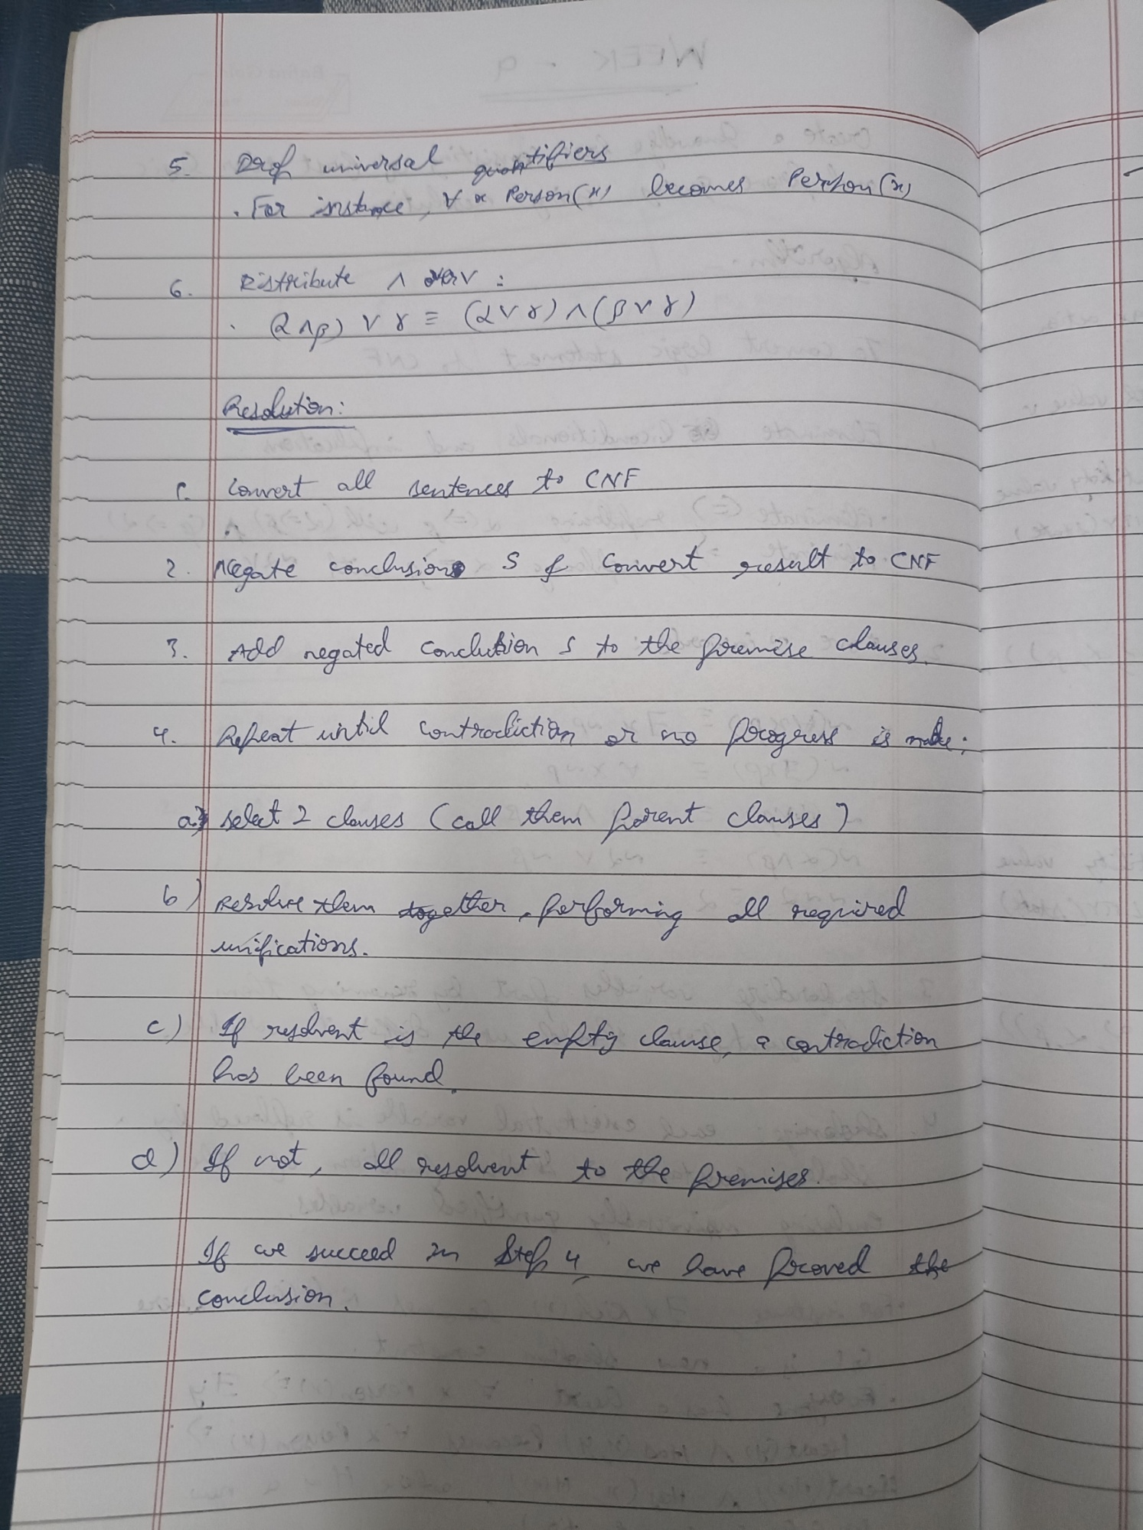

Code:

from copy import deepcopy

from itertools import combinations

# ------------------------------

# Unification Functions

# ------------------------------

def unify(x, y, subst):

    if subst is None:

        return None

    elif x == y:

        return subst

    elif isinstance(x, str) and x.islower():  # variable

        return unify_var(x, y, subst)

    elif isinstance(y, str) and y.islower():  # variable

        return unify_var(y, x, subst)

    elif isinstance(x, list) and isinstance(y, list) and len(x) == len(y):

        return unify(x[1:], y[1:], unify(x[0], y[0], subst))

    else:

        return None

def unify_var(var, x, subst):

    if var in subst:

        return unify(subst[var], x, subst)

    elif x in subst:

        return unify(var, subst[x], subst)

    else:

        subst_copy = deepcopy(subst)

        subst_copy[var] = x

        return subst_copy

def substitute(clause, subst):

    result = []

    for literal in clause:

        pred, args = literal[0], literal[1]

        new_args = [subst.get(arg, arg) for arg in args]

        result.append((pred, new_args))

    return result

# ------------------------------

# Resolution Logic

# ------------------------------

def resolve(ci, cj):

    """Resolve two clauses and return the resolvent if possible."""

    for di in ci:

        for dj in cj:

            if di[0] == f'¬{dj[0]}' or f'¬{di[0]}' == dj[0]:

                subst = {}

                args1, args2 = di[1], dj[1]

                if len(args1) == len(args2):

                    s = unify(args1, args2, subst)

                    if s is not None:

                        new_ci = [x for x in ci if x != di]

                        new_cj = [x for x in cj if x != dj]

                        new_clause = substitute(new_ci + new_cj, s)

                        return new_clause

    return None

def clause_to_str(clause):

    """Pretty print a clause."""

    return " ∨ ".join([f"{p}({', '.join(a)})" for p, a in clause]) if clause else "{}"

# ------------------------------

# Resolution with Tracing

# ------------------------------

def resolution(KB, query):

    clauses = deepcopy(KB)

    neg_query = [(f'¬{query[0]}', query[1])]

    clauses.append(neg_query)

    parents = {}

    step = 1

    print("\n=== Initial Clauses (Knowledge Base + ¬Query) ===")

    for i, c in enumerate(clauses):

        print(f"C{i+1}: {clause_to_str(c)}")

    print("\n=== Resolution Process ===")

    new = []

    while True:

        pairs = list(combinations(range(len(clauses)), 2))

        no_new = True

        for (i, j) in pairs:

            resolvent = resolve(clauses[i], clauses[j])

            if resolvent is not None:

                resolvent_str = clause_to_str(resolvent)

                print(f"\nStep {step}: Resolve C{i+1} and C{j+1}")

                print(f"     {clause_to_str(clauses[i])}")

                print(f"     {clause_to_str(clauses[j])}")

                print(f"  → Inferred: {resolvent_str}")

                step += 1

                if resolvent == []:

                    print("\n🎯 Empty clause derived → Contradiction found!")

                    parents["{}"] = (i+1, j+1)

                    print_resolution_tree("{}", parents, clauses)

                    return True

                if resolvent not in clauses:

                    clauses.append(resolvent)

                    new.append(resolvent)

                    parents[resolvent_str] = (i+1, j+1)

                    no_new = False

        if no_new:

            print("\n❌ No new clauses could be generated — Query cannot be proven.")

            print_resolution_tree("{}", parents, clauses)

            return False

# ------------------------------

# Pretty Tree Printer

# ------------------------------

def print_resolution_tree(root, parents, clauses, indent="", last=True, seen=None):

    """Recursively print resolution tree with indentation."""

    if seen is None:

        seen = set()

    branch = "└── " if last else "├── "

    print(indent + branch + root)

    if root not in parents:

        return

    left_id, right_id = parents[root]

    left_clause = clause_to_str(clauses[left_id - 1])

    right_clause = clause_to_str(clauses[right_id - 1])

    next_indent = indent + ("    " if last else "│   ")

    print_resolution_tree(left_clause, parents, clauses, next_indent, False, seen)

    print_resolution_tree(right_clause, parents, clauses, next_indent, True, seen)

# ------------------------------

# Knowledge Base (FOL Clauses)

# ------------------------------

KB = [

    [('¬food', ['x']), ('likes', ['John', 'x'])],   # ∀x food(x) → likes(John, x)

    [('food', ['Apple'])],

    [('food', ['Vegetables'])],

    [('¬eats', ['x', 'y']), ('killed', ['x']), ('food', ['y'])],  # eats(x,y) ∧ ¬killed(x) → food(y)

    [('eats', ['Anil', 'Peanuts'])],

    [('alive', ['Anil'])],

    [('¬eats', ['Anil', 'x']), ('eats', ['Harry', 'x'])],

    [('¬alive', ['x']), ('¬killed', ['x'])],

    [('killed', ['x']), ('alive', ['x'])]

]

query = ('likes', ['John', 'Peanuts'])

# ------------------------------

# Run Resolution

# ------------------------------

result = resolution(KB, query)

print("\n✅ John likes peanuts!" if result else "\n❌ Query cannot be proven.")

**Program 10**

Implement Alpha-Beta Pruning.

Algorithm:

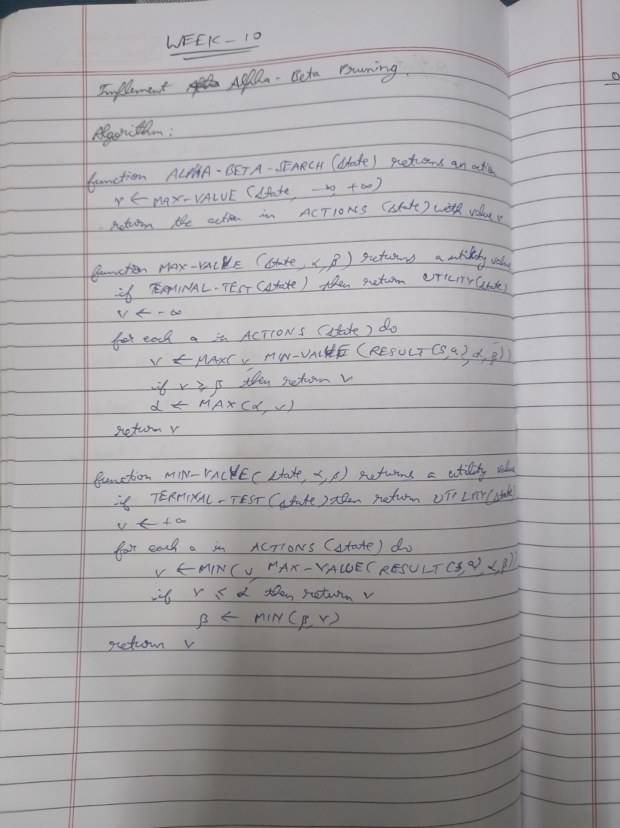

Code:

# Alpha-Beta Pruning Implementation

# ---------------------------------

def alpha_beta_search(state, depth, is_maximizing):

    """Start Alpha-Beta pruning from root."""

    value = alphabeta(state, depth, -float('inf'), float('inf'), is_maximizing)

    print(f"Best value at root: {value}")

    return value

def alphabeta(node, depth, alpha, beta, maximizing_player):

    """Recursive alpha-beta pruning function."""

    # Base Case: Leaf Node or Depth Limit Reached

    if depth == 0 or isinstance(node, (int, float)):  # leaf node

        return node

    # Maximizing player's turn

    if maximizing_player:

        max_eval = -float('inf')

        for child in node:

            eval = alphabeta(child, depth - 1, alpha, beta, False)

            max_eval = max(max_eval, eval)

            alpha = max(alpha, eval)

            print(f"MAX: α={alpha}, β={beta}, value={max_eval}")

            if beta <= alpha:  # β cutoff

                print(">> Beta cutoff!")

                break

        return max_eval

    # Minimizing player's turn

    else:

        min_eval = float('inf')

        for child in node:

            eval = alphabeta(child, depth - 1, alpha, beta, True)

            min_eval = min(min_eval, eval)

            beta = min(beta, eval)

            print(f"MIN: α={alpha}, β={beta}, value={min_eval}")

            if beta <= alpha:  # α cutoff

                print(">> Alpha cutoff!")

                break

        return min_eval

# Example Game Tree (same structure as in your image)

# Represented as nested lists

tree = [

    [ [10, 9], [14, 18] ],  # Left subtree

    [ [4, 50], [3] ]        # Right subtree

]

# Run Alpha-Beta pruning on this tree

alpha_beta_search(tree, depth=3, is_maximizing=True)